Annual Report 2020-2021

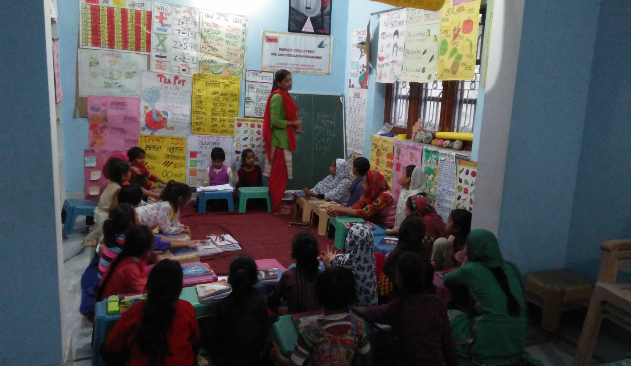

Institute for Development Support (IDS)

Annual Report 2020-2021

A BRIEF PROFILE OF INSTITUTE FOR DEVELOPMENT SUPPORT
Institute for Development Support (I.D.S) is a registered autonomous non-governmental organization, established in 1993-94 and based in Pauri Garhwal, Uttarakahnd. IDS works with rural, urban communities of the Himalayan region with the prime motto of empowerment of the society. The organization believes in an integrated development of Man and Nature and actively involves the stakeholders in implementation of innovative programs in the rural, urban areas of Uttarakhand. IDS mantra is to facilitate mountain communities to know and understand their own strength so that they could participate in the developmental and environmental activities. The organization aims at helping people utilize their inherent potential to improve their well-being through self awareness and use of traditional wisdom. IDS has multidisciplinary team of professionals including development planners, extension workers and trainers having many years of experience in project development, implementation, capacity building, monitoring and evaluation.

Vision of the organization
To create an empowered and self reliant society

Mission of the organization
To develop and implement innovative, multidisciplinary developmental programs that are sustainable and replicable.
Objectives of the organization
- To improve socio-economic status of the society.
- To Implement integrated rural development programs for the sustainable development of the society
- To organize capacity building programs for the enhancement of knowledge, skill and entrepreneurship development.
- To create awareness and plan, implement, monitor and evaluate programs related to Education, health, Livelihood, and environment rehabilitation
- To build capacity of community based organization, women groups and panchayati raj institutions in natural resource management.
- To implement awareness programs for the eradication of various social evils prevailing in the society.
- To introduce various appropriate technologies such as rain water harvesting, biogas, solar energy, composting, solid, liquid waste management, pasture and fodder development, soil-water conservation etc.
- Publication and production of books, magazines, newsletters, posters, films, audios and videos.
Partners
- Water Supply and Sanitation Collaborative Council, an UN unit
- UNIDO (United nation Industrial Development Organization, Vienna, Austria )
- Integrated Livelihood Support Program-IFAD, Govt of Uttarakhand
- Uttarakhand Tourism Development Board, Govt of Uttarakhand
- WISIONS,Wuppertal Institute for Climate, Environment and Energy, Germany
- IIMPACT, Gurugram Haryana.
- Indo German Energy Program, GIZ, New Delhi
- National Bank for Agriculture and Rural Development (NABARD)
- Forest Department, Government of Uttarakhand
- Jal Sansthan and Jal Nigam, Government of Uttarakhand
- District Administration, Pauri Garhwal
- Health Department, Government of Uttarakhand
- Sir Ratan Tata Trust (SRTT), Mumbai
- District Project Management Unit (DPMU), SWAJAL, Department of Drinking Water, Government of Uttarakhand
- Uttarakhand Renewable Energy Development Agency (UREDA), Government of Uttarakhand
- Shri BhuvneshwariMahila Ashram/ PLAN International
- World Vision, Pauri Garhwal
- Department of Science and Technology, Govt. of India
- Indian Institute of Technology, Roorkee
- CDM Smith Associates Inc. Banglore.
- HIFEED, Ranichounri, Tehri Garhwal
- M/S Karvy Pvt Ltd
- Centre for Environmental Education, Lucknow
- IT Power synergy services Ltd, Gurgoan
- Department of Planning and Statistics, GoUK
- IL&FS Pvt. Limited, New Delhi

Institute for Development Support is working in more than 200 villages of 12 districts of Uttarakhand and slum area of Delhi in the following areas.
- Economic Empowerment: The program is focused to promote agriculture & horticulture based livelihood of the local community, training, capacity building, and vocational training to youths on different livelihood options. In addition to this the program is also focused to establish the community based micro finance groups or women SHGs engaged in micro enterprises for their livelihood enhancement. Many trainings and capacity building programs were organized in vegetable farming, bee keeping, dairy development, spices cultivation, mushroom farming, fruit processing, nursery development, poultry, marketing of the products and non farm activities such as re-cycling of waste material and development of products in rural and urban areas.
- Community Based Tourism:IDS has been engaged in planning, implementation, monitoring and supervision of community based tourism activities in 12 districts of Uttarakhand for livelihood enhancement. The key activities being performed under the projects are identification of suitable villages for tourism development, IEC, formation and management of village tourism development committee, eco development committee, identification of their training need, designining and implementation of training in hospitability management, cooking, bird watching, interpretation, nature guiding, low cost dwelling units, business plan preparation, linkages with parytanswarojgaryojna and established linkages with marketing agencies.
- Water & Environment Sanitation: IDS has facilitated planning and implementation of many rural water and environmental sanitation schemes in the villages of Uttarakhand supported under Sector Wide Approach and total sanitation campaign. IDS empowered community based organization particularly village water and sanitation committees to execute safe water supply and sanitation program for sustainable health and hygiene. An innovative, solar lifting water scheme was also constructed to fulfill the need and demand of the villagers. Apart from this, IDS is facilitating construction of household sanitary toilets, school sanitation and environmental sanitation.
- Gender Empowerment: Under this program, the organization is generating awareness among community members, PRIs, women groups, government officials/institutions, children groups on gender equity and equality. Capacity building training of youth & women on different issues/skills, government law & policies are also the part of the program.
- Renewable energy for livelihood development: Organization is engaged in implementation of programs that promote clean, green renewable energy to mitigate the adverse impact of climate change. To generate awareness among community members about green energy, IDS has organized several Green techno fairs or exhibition in Uttarakhand. Traditionally watermills have been source of clean energy and mechanical power to grind food grains in Uttarakhand. IDS has also been engaged in installation of model water mill and improvement of traditional water mill for electricity generation as well. The local communities residing nearby the watermill were organized into SHGs for the processing, packaging marketing of watermill processed products for livelihood enhancement.
- Education & Health Program: IDS is regularly involved into improvement in formal and informal education program with communities. Organization operating 130 Education Center for the girl child who could not attended formal schooling or drop out from the school in Dehradun and Himachal. Apart from this IDS also promoted eco clubs in the 150 school for imparting better environmental education to children. Child right is another key area where organization has organized many advocacy programs. IDS implemented reproductive child health program that include preparation of birth plans, educating & mobilizing mothers for early registration, complete vaccination, IFA distribution, institution delivery and other health & hygiene issues. In addition to this the program is also focused to educate adolescents on reproductive & sexual health, conduction of health camps in remote area, regular school level camps, regular counseling, eradication of female foeticide and treatment of mal-nourished children etc.
- Natural Resource management
The economy of Uttarakhand is more dependent on natural resources. The condition of the natural resources is deteriorating day by day. Considering the facts, IDS have been regularly engaged in conservation and protection of natural resource through community institution such as van panchayats, PRI, SHGs and Mahila Mangal Dals. The key program organized under the components are formation and strengthening of van panchayats, imparted different capacity building trainings to committee members and villagers, supported to committee members for nursery development, plantation, trenching, construction of ponds and rain water harvesting tanks.
Management structure
The executive board of the IDS is apex body which provides guidance and takes final decision regarding growth of the institution. The Executive Director nominated by the apex body is responsible for the implementation of the decision taken by the board. Executive Director provides guidance and assistance to staff, project team and field facilitator for effective planning and implementation of the programs. IDS has separate Project Coordinator or Team Leader and experts for the projects being implemented by the IDS.
Executive Body
Executive Director
Program Coordinator

Program Coordinator
Program Coordinator

Field Facilitators

Field Facilitators

Field Facilitators

Admin &Finance Officer

Subject specialist

Summary of projects Activities carried out by Institute for Development Support during 2020-21

S.N. | Project name/ Place | Beneficiary | Funding from
1 | Implementation of Menstrual Hygiene Management training activities for Swachh Bharat Mission-Gramin (Clean India Mission in Rural Areas) | Govt, Non govt functionaries of Assam, Bihar, Jharkhand, Uttarakhand, Maharashtra, UP, West Bengal and Chattisgarh | Water Supply and Sanitation Collaborative Council (WSSCC), United Nation of Project Services, Geneva
2 | RAPID ACTION LEARNING (RAL) Activities for Swachh Bharat Mission (Gramin) | Govt, Non govt functionaries of Assam, Bihar, Jharkhand, and UP, | Water Supply and Sanitation Collaborative Council (WSSCC), United Nation of Project Services, Geneva
3 | Girls Child EducationProgram | 35 villages of Dehradun and 20 villages of Sirmaur district in Himachal Pradesh | IIMPACT, Gurugram, Haryana

PROJECT-1: IMPLEMENTATION OF MENSTRUAL HYGIENE MANAGEMENT (MHM) TRAINING ACTIVITIES FOR SWACHH BHARAT MISSION-GRAMIN (CLEAN INDIA MISSION IN RURAL AREAS)
The Water Supply and Sanitation Collaborative Council (WSSCC) is a UNOPS hosted entity devoted to the sanitation and hygiene needs of the most vulnerable people in Africa and Asia. It works directly with national and local government and in partnership with civil society and the private sector to enable and strengthen universal sanitation access and use and helps ensure that government policies prioritize equal access to sanitation for women, girls, and marginalized individuals and groups.

Water Supply and Sanitation Collaborative Council (WSSCC) is a development partner of the Ministry of Drinking Water and Sanitation (MDWS), Government of India (GOI) for the implementation of its national flagship program, Swachh Bharat Mission-Gramin (SBM-G, or Clean India Mission – Rural Areas).
The Grant Support Agreement has been made between the United Nations Office for Project Services acting as host agency of the Water Supply and Sanitation Collaborative Council (WSSCC) and Institute for Development Support (IDS) for “Implementation of MHM training activities for the Swachh Bharat Mission-Gramin (Clean India Mission in Rural Areas)

Objective of the MHM Grant:
The main objectives of the grant support activities will be to provide organizational capacity in the form of human resource management for:
• The creation of a pool of MHM Trainers using WSSCC’s approach
• Set up and deployment of training teams for the implementation of training programs on MHM

Key activities under this Grant Support Agreement:
- Provide technical support through consultant hire from an agreed roster to support SBM-G work on (ODF, ODF Plus and MHM). Consultant tasks to be agreed and coordinated with India Support Unit (ISU)

- Provision of support for the organization of a five-day orientation workshop for the selected trainers on WSSCC’s approach to MHM in Bihar, Jharkhand, UP, Assam, Uttarakhand, West Bengal, Maharastra, and Chattisgarh

- Coordinate in deployment of trainers to the training program locations (in agreement with the ISU coordinator and following demand from district authorities).

Key Outcome:
Logistical and management support is provided to WSSCC/ISU for the orientation and deployment of facilitators to implement MHM workshops/activities under the SBM-G in 2019.

Duration of the Assignment
All activities under the assignment are conducted during the period of April 2020 and December 2020 with a period for financial closure until 15 February 2021.

Key activities performed under the assignment

Milestone 1 (to be completed by 10th June): Completion of MHH Coordinator hire to support SBM-G work on (MHH and ODF Plus in agreement with ISU)
- MHH Coordinator was hired by IDS to coordinate for all activities under the MHM Grant in agreement with ISU Coordinator, post inviting applications, screening and further conducting interviews for the same.
Milestone 2 (to be completed by 10th June) :Completion of State Motivator hire for the MHH advocacy in all schools inJharkhand.
- A State Motivator for the MHH advocacy in all schools in Jharkhand was hired by IDS after conducting interviews with the candidates recommended by the state government with ISU Coordinator
Milestone 3 (to be completed by 10th June): Report on completion of 5 MHH ToTs on WSSCC approach.
- Due to Covid-19 Pandemic, the country was on a complete lockdown until 8th June. Hence, 5-day MHH ToT’s could not take place. However, instead eight 1-day MHH trainings were conducted before 10th June that trained 272 participants. These trainings were conducted in Maharashtra, Jharkhand, U.P, Ladakh, Assam.The following section gives an overview of the MHH training workshops in year 2020 including spillover trainings from 2019:

 | TRAININGS CONDUCTED FROM APRIL to JUNE 2020
S.NO | Date of Training Conducted |  | Organization | Name of the Trainer | Profile of Participants | No. of Participants
 | ONE DAY ONLINE TRAININGS
1 | 7th May | Yashwant College, MGM College, Matoshri Engineering College and SRTM University (Swani Ramanand Terth University) |  | Surekha Lambe | College Girls from colleges in Nanded, Maharashtra | 15
2 | 10th May 2020 | Leduka Panchayat, Block-Buxa, Jaunpur. U.P. |  | Dinesh Pandey | With SHG groups and college girls , Jaunpur, U.P | 57
3 | 15th May 2020 | Knowledge Links-West Bengal, College of Social Work-Amravati Maharashtra, |  | Krishna Rmavat | Volunteers from NGOs. | 40
4 | 16th May 2020 | Sulabh International |  | Surekha Lambe | Student volunteers from delhi, Rajasthan, Sikkim, West Bengal, Maharashtra andBihar | 27
5 | 31st May | Ethical tea Partnership |  | Ishleen | Tea garden Communities. Assam | 63
6 | 29th May | Lantern Edusports Foundation |  | Princi | Staff members of Lantern Edusports, Mumbai | 19
7 | 6th June | Pinnacle International School |  | Surekha Lambe | Adolescent girls from school, Nanded, Mahrashtra | 31
8 | 8th June | rZamba |  | Princi | Staff from rZamba, Kargil, Ladakh | 20
Milestone 4 (to be completed by 10th June): Completion of 5 capacity building programs in MHH for the advocacy in allschools in Jharkhand
- Due to Covid-19 Pandemic, the country was on a complete lockdown until 8th June resulting a lockdown in all government operations. However, during the same the MHH Coordinator, Jharkhand undertook the following tasks:
- Issued letter from Director SBM-G, DW&SD to conduct MHH orientation in 6 districts of Jharkhand which are taking place in the month of July. The training sessions are for frontline workers which include Jalsahiya, Block coordinators, Social mobilizer, active SHG members and teachers of government school.
- Designed IEC calendar of SBM-G for state government.
- Prepared questionnaires to initiate need assessment of teachers and students in schools.
- Planned for sustainable and research-based project on MHH in schools and drafted a concept note for the same.
- Supported in content creation for MHDAY social media campaign by getting video clips of frontline workers from Jharkhand to show the change brought by them after training on MHH.Ensured Social Media Reporting.

Milestone 5 (To be completed by 30th May 2020): Completion of required grant reports (narrative and financial)
- The report was submitted on the due date.

Milestone 6 (To be completed by 30th September): Completion of 5 MHH ToTs on WSSCC approach
- Due to COVID-19 pandemic, there were restrictions imposed on travel and holding big gatherings hence as shared in note to file during the Pandemic times, instead of a full residential 5-day MHM ToTs after February 2020. One day Face to face trainings resumed from July onwards and 5 day face to face trainings resumed from September onwards.The face-to-face trainings were held in small groups and keeping in mind all the social distancing norms.
- To continue with the activities, the trainers were encouraged to organize 1-day MHH trainings as feasible through physical sessions or through online meeting platforms. An online orientation was done for MHH trainers on the ‘COVID 19- Menstrual Health Hygiene Safe Practices’ to sensitize about the impact of COVID on MHH practices, adapting the MHH trainings in the wake of COVID and appropriate messaging on MHH and COVID such as special emphasis on handwashing and hygiene. The training participants included community health workers, teachers, educators, frontline workers, tea garden communities, self-help group women, adolescent girls and boys, NGO staff, college girls and boys etc.
- The trainings for teachers, ASHAs, Sanginis were conducted with an aim to create a resource pool of trainers who will be able to further sensitize and train women using the WSSCC three-pronged approach on MHH. The online webinars were conducted using Zoom platform and presentations and open discussions were used by trainers to ensure engagement of the participants. Some of the key topics explained and discussed during trainings include:
  - Explaining the biological process of menstruation and breaking the myth of impurity of menstrual blood.
  - Discussing how the culture of silence and social taboos around menstruation impact the lives of women and girls and the ways to systematically question and address the taboos.
  - 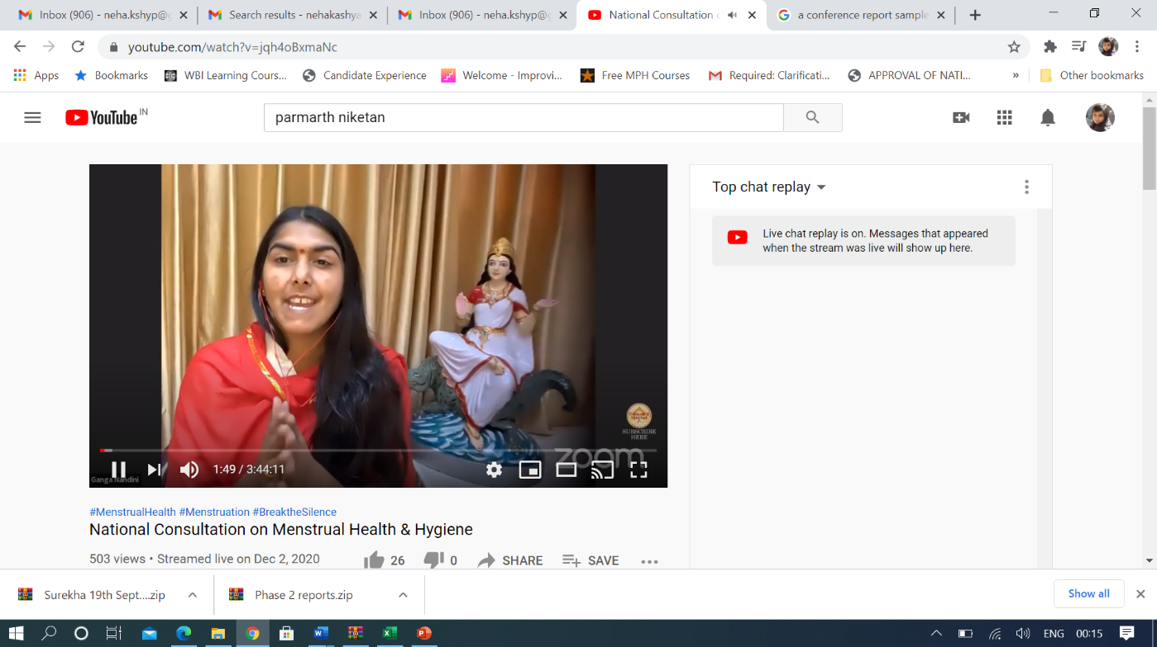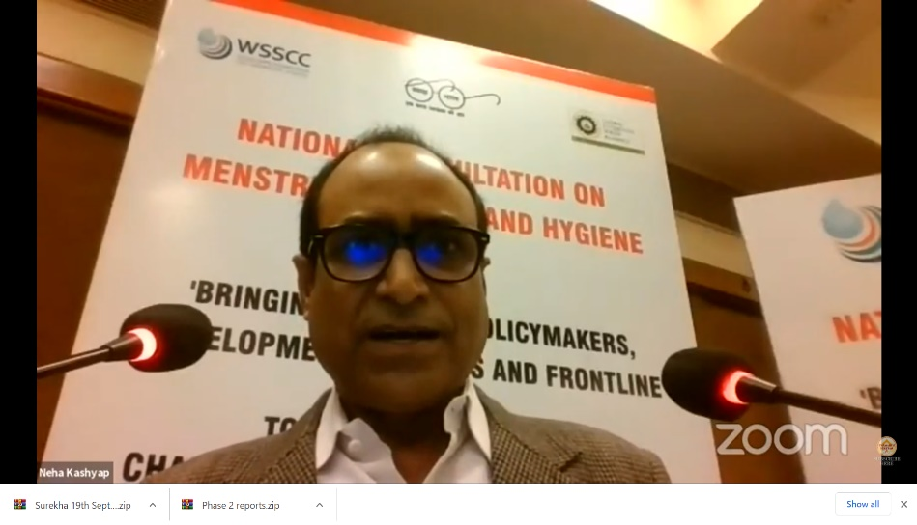Describing safe practices that women and girls should adopt to manage their menstruation hygienically.
Ms.Ganga Nandini and Mr. Vinod Mishra welcoming speakers and participants
  - Demonstration of the range of menstrual absorbents available along with their pros and cons.
  - Learning about safe disposal of menstrual waste.
  - Safe hygiene practices to be adopted for MHH in wake of COVID.
- During the year, a total 103 trainings were conducted for of 3977 participants were trained in MHH through following modes and formats of training from 10th June to 30th November 2020:
  - 9 five-day face to face trainings that trained 376 participants.
  - One day online trainings- 24 trainings that trained 858 participants.
  - One day face to face trainings- 46 trainings that trained 1319 Participants.
  - One four-day online training that trained 73 participants.
  - 23 one day ToT for Patna School teachers that trained 1351 participants from 23 blocks of Patna. The details are given in following section.

TRAININGS CONDUCTED FROM JUNE ONWARDS
S.No. | Date of Training Conducted | Organization | Name of the Trainer | Profile of Participants | No. of Participants
ONE DAY ONLINE TRAININGS
9 | 12th June | Pratibimb Foundation | Shailesh | SHG women and staff from foundation, Mirzapur, Uttar Pradesh | 25
10 | 13th June | Ethical tea Partnership | Ishleen | Tea garden Communities. Assam | 54
11 | 16th June | Maharashtra State Rural Livelihoods Mission | Surekha Lambe | SHG women | 67
12 | 17th June | U.P Rural Livelihoods Mission | Ziyaul Haque | SHG women Ahiroura, sumerpur block , Kanpur | 24
13 | 23rd June | Ushakal Organization | Krishna Ramavat | Women and adolescent girls, Seloo Block, Wardha, Maharasthtra | 25
14 | 24th June | U.P Rural Livelihoods Mission | Ziyaul Haque | SHG women, Tularam khera , Kanpur | 38
15 | 26th June | RKS & Sickle cell Control Program under NRHM | Krishna Ramavat | RKSK program team and adolescent girls, Yavatmal, Mharashtra | 30
16 | 26th June | U.P Rural Livelihoods Mission | Ziyaul Haque | SHG Women. Rasoolpur, Unnao, U.P | 52
17 | 29th June | U.P Rural Livelihoods Mission | Ziyaul Haque | SHG Women, Tularap Kheda, Unnao, U.P | 67
18 | 29th June | U.P National Health Mission | Krishna Ramavat | Adoloscent girls, Maharajganj U.P | 44
19 | 30th June | Jharkhand Education Government | Ishleen and Surbhi | Teachers, Jalsahiya and Mukhiyas of Jharkhand Govt. | 36
20 | 2nd July | Kargil School | Ishleen | School Students | 25
21 | 7th July | Ambedkar college of social work | Krishna Ramavat | College Students | 33
22 | 7th July | Jharkhand Education Government | Princi | Teachers, Jalsahiya and Mukhiyas of Jharkhand Govt. | 39
23 | 10th July | Mahila Jan Kalyan Sewa Samiti , Madhya Pradesh | Krishna Ramavat | Adolescent girls and SHG women from Khanwa District. | 34
24 | 12th July | District Rural Development Institute | Ziyaul Haque | Samooh Sakhi, Unnao | 25
25 | 14th July | District Rural Development Institute | Ziyaul Haque | Samooh Sakhi, Unnao
26 | 14th July | Jharkhand _Latehar District-SBMG | Krishna Ramavat | SHG, Jalsahiya, Coordinators and social mobilizers | 44
27 | 16th July | Sane guruji mandal, Faith Based Organization | Krishna Ramavat | Adolescent girls and women | 25
28 | 17th July | Jharkhand-SBM-G | Dr. Surubhi Singh and Isha | Teachers, Jalsahiya and Mukhiyas of Jharkhand Govt. | 47
29 | 22nd July | Simdega District, SBM-G | Surekha Lambe | Ranchi. Jharkhand Teachers, Jalsahiya and Mukhiyas of Jharkhand Govt. | 40
30 | 30th July | SSP, Pune | Surekha Lambe | Community Resource Persons | 27
31 | 5th August | Nehru Yuva Kendra Nanded Maharashtra | Surekha Lambe | NYK Volunteers | 30
32 | 19th September | KGBV, Parabani,Maharashtra | Surekha Lambe | 27 adolescents, 4 female’s Teachers | 27
ONE DAY FACE TO FACE TRAININGS
33 | 31st July | Department of Health and Family welfare, Mainpuri District, UP | Meenu Chauhan | ASHA members and Sangini -Barnahal Block | 29
34 | 1st August | Department of Health and Family welfare, Mainpuri District, UP | Meenu Chauhan | ASHA members and Sangini -Barnahal Block | 29
35 | 2nd August | Department of Health and Family welfare, Mainpuri District, UP | Meenu Chauhan | ASHA members and Sangini -Barnahal Block | 29
36 | 4th August | Department of Health and Family welfare, Mainpuri District, UP | Meenu Chauhan | ASHA members and Sangini -Manpurahari Block | 29
37 | 5th August | Department of Health and Family welfare, Mainpuri District, UP | Meenu Chauhan | ASHA members and Sangini -Manpurahari Block | 28
38 | 6thAugust | Department of Health and Family welfare, Mainpuri District, UP | Meenu Chauhan | ASHA members and Sangini -Manpurahari Block | 29
39 | 7th August | Department of Health and Family welfare, Mainpuri District, UP | Meenu Chauhan | ASHA members and Sangini -Manpurahari Block | 29
40 | 8th August | Department of Health and Family welfare, Mainpuri District, UP | Meenu Chauhan | ASHA members and Sangini -Jagir Block | 29
41 | 9th Aughust | Department of Health and Family welfare, Mainpuri District, UP | Meenu Chauhan | ASHA members and Sangini -Jagir Block | 28
42 | 10th August | Department of Health and Family welfare, Mainpuri District, UP | Meenu Chauhan | ASHA members and Sangini -Kishni Block | 28
43 | 11th August | Department of Health and Family welfare, Mainpuri District, UP | Meenu Chauhan | ASHA members and Sangini -Kishni Block | 28
44 | 13th August | Department of Health and Family welfare, Mainpuri District, UP | Meenu Chauhan | ASHA members and Sangini -Kishni Block | 27
45 | 14th August | Department of Health and Family welfare, Mainpuri District, UP | Meenu Chauhan | ASHA members and Sangini -Kishni Block | 27
46 | 15th August | Department of Health and Family welfare, Mainpuri District, UP | Meenu Chauhan | ASHA members and Sangini -Kurawali Block | 30
47 | 16th August | Department of Health and Family welfare, Mainpuri District, UP | Meenu Chauhan | ASHA members and Sangini -Kurawali Block | 27
48 | 17th August | Department of Health and Family welfare, Mainpuri District, UP | Meenu Chauhan | ASHA members and Sangini -Kurawali Block | 28
49 | 18th August | Department of Health and Family welfare, Mainpuri District, UP | Meenu Chauhan | ASHA members and Sangini -Kuchaila Block | 30
50 | 19th August | Department of Health and Family welfare, Mainpuri District, UP | Meenu Chauhan | ASHA members and Sangini -Kuchaila Block | 29
51 | 20th August | Department of Health and Family welfare, Mainpuri District, UP | Meenu Chauhan | ASHA members and Sangini -Kuchaila Block | 29
52 | 21st August | Department of Health and Family welfare, Mainpuri District, UP | Meenu Chauhan | ASHA members and Sangini -Kuchaila Block | 30
53 | 22nd August | Department of Health and Family welfare, Mainpuri District, UP | Meenu Chauhan | ASHA members and Sangini -Sultanganj | 28
54 | 23rd August | Department of Health and Family welfare, Mainpuri District, UP | Meenu Chauhan | ASHA members and Sangini -Sultanganj | 27
55 | 24th August | Department of Health and Family welfare, Mainpuri District, UP | Meenu Chauhan | ASHA members and Sangini -Sultanganj | 27
56 | 25th August | Department of Health and Family welfare, Mainpuri District, UP | Meenu Chauhan | ASHA members and Sangini -Sultanganj | 28
57 | 26th August | Department of Health and Family welfare, Mainpuri District, UP | Meenu Chauhan | ASHA members and Sangini -Karhal | 30
58 | 27th August | Department of Health and Family welfare, Mainpuri District, UP | Meenu Chauhan | ASHA members and Sangini -Karhal | 28
59 | 28th August | Department of Health and Family welfare, Mainpuri District, UP | Meenu Chauhan | ASHA members and Sangini -Karhal | 27
60 | 29th August | Department of Health and Family welfare, Mainpuri District, UP | Meenu Chauhan | ASHA members and Sangini -Ghiror | 27
61 | 30th August | Department of Health and Family welfare, Mainpuri District, UP | Meenu Chauhan | ASHA members and Sangini -Ghiror | 28
62 | 31st August | Department of Health and Family welfare, Mainpuri District, UP | Meenu Chauhan | ASHA members and Sangini -Ghiror | 27
63 | 18thJuly | U.P Rural Livelihoods Mission | Ziyaul Haque | Kannauj, U.P , Internal Community Resource Persons Social mobilisation( | 27
64 | 19th July | U.P Rural Livelihoods Mission | Ziyaul Haque | Kannauj, U.P , Internal Community Resource Persons Social mobilisation( | 28
65 | 23rdJuly | Samarpan Pratishthan | Krishna Ramavat | Raksha Village,Tarubanda | 27
66 | 25th July | Samarpan Pratishthan | Krishna Ramavat | tingrya Village, Dharni Block | 26
67 | 6thAugust | District Rural Development Institute (DIRD) -Samooh Sakhi | Ziyaul Haque | SHG Women, DIRD, Unnao | 29
68 | 13th August | Association of Advocacy and Legal Initiatives (AALI) | Ziyaul Haque | Staff members of Aierai Development Block | 31
69 | 19th August | 3 SHGs, Dagraiya Village | Ziyaul Haque | SHG women, Malwa Block | 30
70 | 20th August | Social Work Committee of Uttar Pradesh State Rural Livelihoods Mission | Ziyaul Haque | SHG women, Regional Rural Development Institute Bakwer, District Etawah, | 25
71 | 21st August | National Rural Livelihoods Mission | Ziyaul Haque | SHG women, Regional Rural Development Institute Bakwer, District Etawah, | 29
72 | 23rd August | District Rural Development Institute (DIRD) | Ziyaul Haque | SHG Women, Hardoi | 30
73 | 25th August | Cluster Level Federation, Telyani Block | Ziyaul Haque | Adolescent girls and women, Telyani Block, Fatehpur | 31
74 | 26th August | District Rural Development Institute (DIRD), Unnao | Ziyaul Haque | SHG women, Unnao | 40
75 | 27th August | Gulab Mahila Prerna Mahila Sangathan (Cluster Level) Federation) Development | Ziyaul Haque | Women, Block-Sikanderpur Karan, Unnao | 25
76 | 29th September | Magarwara | Zia U Haque | Women and community, Magarwara Block, Unnao | 30
77 | 17th July | U.P Rural Livelihoods Mission | Meenu Chauhan | SHG Workers | 32
78 | 18th July | U.P Rural Livelihoods Mission | Meenu Chauhan | SHG Workers | 30
FIVE DAY FACE TO FACE TRAININGS
79 | 21- 25th September | Shramik Bharti (face to face) | Dinesh Pandey (Lead) | SHG members- women | 35
80 | 26th- 30th September | Shramik Bharti (face to face) | Anupam Pandey (Lead) | SHG members- women | 44
81 | 5th-9th October | Shramik Bharti (face to face) | Utkarsh Dwivedi with Radhe Sham and Amitabh Singh | SHG members- women | 44
82 | 11th-15th October | Shramik Bharti (face to face) | Utkarsh Dwivedi with Radhe Sham and Amitabh Singh | Block Akbarpur, Kanpur Dehat, Women from Self-help groups- Women | 36
83 | 27 Sept to 1 Oct | FINISH Society, Mirzapur | FINISH trainers | Community Health Facilitators (CHFs) | 46
84 | 12th to 16th October | FINISH Socety, Bikramjot | FINISH trainers | Community Health Facilitators (CHFs) | 45
85 | 5-9 October | FINISH Society, Akbarpur | FINISH trainers | Community Health Facilitators (CHFs) | 50
86 | 5-9 October, 2020 | FINISH Society, Jaunpur | FINISH trainers | Community Health Facilitators (CHFs) | 38
87 | 10 to 14 October, 2020 | FINISH Society, Jaunpur | FINISH trainers | Community Health Facilitators (CHFs) | 38
FOUR DAY ONLINE TRAINING
88 | 6th -8th October | Aga Khan Foundation (Online) | Ishleen, Ziyaul Haque and Pranami | Community staff of Aga Khan Foundation | 73
BIHAR EDUCATION DEPARTMENT
89 | 21st September | Bihar Education Department | Ishleen | Bihata Block Education Officers | 108
90 | 22nd September | Bihar Education Department | Krishna | Phulwari Block Education Officers | 44
91 | 22nd September | Bihar Education Department | Surekha | Naubatpur Block Education Officers | 49
92 | 23rd September | Bihar Education Department | Suman Pandey | Bhaktiyarpur Block Education Officers | 50
93 | 23rd September | Bihar Education Department | Ziya Ul Haque | Fatuha Block Education Officers | 100
94 | 24th September | Bihar Education Department | Susmita | Bazar Block Education Officers | 100
95 | 24TH September | Bihar Education Department | Pranami | Khusrupur Block Education Officers | 100
96 | 25th September | Bihar Education Department | Nazia | Maner Block Education Officers | 50
97 | 26th September | Bihar Education Department | Anupam Pandey | Punpun Block Education Officers | 50
98 | 29th September | Bihar Education Department | Prashant | Block Education Officers | 50
99 | 30th September | Bihar Education Department | Prashant | Block Education Officers | 50
100 | 3rd October | Bihar Education Department | Prashant | Block Education Officerx | 50
101 | 3rd October | Bihar Education Department | Pratibha D Mello | Block Education Officers | 50
102 | 5th October | Bihar Education Department | Prashant | Block Education Officers | 50
103 | 5th October | Bihar Education Department | Prashant | Block Education Officers | 50
104 | 9th October | Bihar Education Department | Prashant | Block Education Officers | 50
105 | 10th October | Bihar Education Department | Prashant | Block Education Officers | 50
106 | 12th October | Bihar Education Department | Prashant | Athamalgola Block Education Officers | 50
107 | 13rd October | Bihar Education Department | Prashant | Barh Block Education Officers | 50
108 | 15th October | Bihar Education Department | Prashant | Pandarak Block Education Officers | 50
109 | 16th October | Bihar Education Department | Prashant | Belchhi Block Education Officers | 50
110 | 16th October | Bihar Education Department | Prashant | Sampatchak Block Education Officers | 50
111 | 17th October | Bihar Education Department | Prashant | Mokama Block Education Officers | 50
TOTAL |  |  |  |  | 3977

Milestone 7 (To be completed by 30th September): Completion of 5 capacity building programs in MHH for the advocacy in all schools in Jharkhand
- Despite the Covid-19 Pandemic, advocacy was done with the Jharkhand Education department and one day online webinar trainings were conducted with teachers from schools of Jharkhand. An online orientation was done for 1-2 teachers of all the secondary and higher secondary schools of 260 blocks in 24 districts. A total of 1834 teachers were trained from all districts were trained in 29 one day online trainings conducted after 10th June. The trainings for teachers were conducted with an aim to create a resource pool of trained teachers who will be able to further sensitize and train children using the WSSCC three-pronged approach on MHH. The details and profile of participants in the training is given in table below.
S.No. | Date of Training Conducted | Organization | Name of the Trainer | Profile of Participants | No. of Participants
1 | 14th August | Education Department-Govt of Jharkhand | Surekha Lambe | Teachers, Seraikela | 36
2 | 18th August | Education Department-Govt of Jharkhand | Princi | Teachers Hazaribagh | 22
3 | 26th August | Education Department-Govt of Jharkhand | Krishna | Teachers Chatra | 25
4 | 27th August | Education Department-Govt of Jharkhand | Ishleen | Teachers, Giridih | 26
5 | 1st September | Education Department-Govt of Jharkhand | Surekha Lambe | Teachers Ranchi , West Singhbhum | 28
6 | 13th October | Education Department-Govt of Jharkhand | Krishna | Teachers Government Schools Jamtara | 100
7 | 14th October | Education Department-Govt of Jharkhand | Surekha | Teachers Government Schools Simdega | 98
8 | 16th October | Education Department-Govt of Jharkhand | Krishna | Teachers Government Schools Ranchi | 71
9 | 19th October | Education Department-Govt of Jharkhand | Surekha | Teachers Government Schools Deoghar | 76
10 | 20th October | Education Department-Govt of Jharkhand | Krishna | Teachers Government Schools, Dumka | 122
11 | 20th October | Education Department-Govt of Jharkhand | Pratibha D Mello | Teachers Government Schools, Khunti | 50
12 | 21st October | Education Department-Govt of Jharkhand | Pranami | Teachers Government Schools, Ramgarh | 100
13 | 21st October | Education Department-Govt of Jharkhand | Krishna | Teachers Government Schools, Dhanbad | 41
14 | 22nd October | Education Department-Govt of Jharkhand | Surekha | Teachers Government Schools Hazaribagh | 99
15 | 23rd October | Education Department-Govt of Jharkhand | Pranami | Teachers Government Schools, Pakur | 46
16 | 26th October | Education Department-Govt of Jharkhand | Ishleen | Teachers Government Schools, Godda | 50
17 | 27th October | Education Department-Govt of Jharkhand | Surekha | Teachers Government Schools Sahibaganj | 50
18 | 27th October | Education Department-Govt of Jharkhand | Krishna | Teachers Government Schools East Singhbhum | 91
19 | 28th October | Education Department-Govt of Jharkhand | Surekha | Teachers Government Schools West Singhbhum | 49
20 | 28th October | Education Department-Govt of Jharkhand | Dinesh Pandey | Teachers Government Schools Latehar | 58
21 | 29th October | Education Department-Govt of Jharkhand | Ishleen | Teachers Government Schools Bokaro | 94
22 | 29th October | Education Department-Govt of Jharkhand | Krishna | Teachers Government Schools Gadhwa | 91
23 | 30th October | Education Department-Govt of Jharkhand | Pranami | Teachers Government Schools Palamy | 24
24 | 2nd November | Education Department-Govt of Jharkhand | Dinesh Pandey | Teachers Government Schools Chhatar | 51
25 | 3rd November | Education Department-Govt of Jharkhand | Pranami | Teachers Government Schools Saraikela | 49
26 | 4th November | Education Department-Govt of Jharkhand | Dinesh Pandey | Teachers Government Schools Giridh | 94
27 | 4th November | Education Department-Govt of Jharkhand | Dinesh Pandey | Teachers Government Schools Koderma | 91
28 | 5th November | Education Department-Govt of Jharkhand | Ishleen | Teachers Government Schools Loharadaga | 50
29 | 6th November | Education Department-Govt of Jharkhand | Dinesh Pandey | Teachers Government Schools Gumla | 52
TOTAL |  |  |  |  | 1834

- 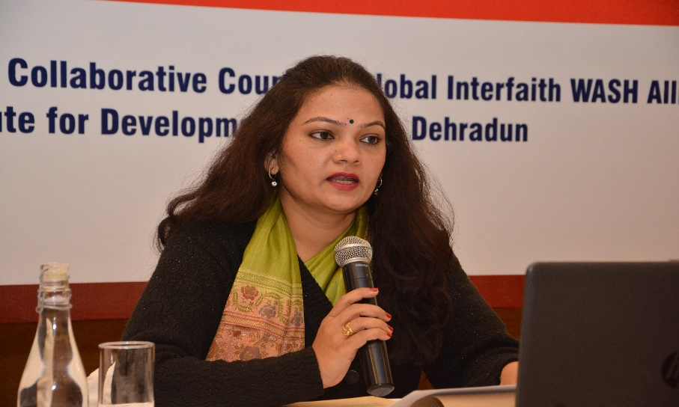A refresher training was conducted with the 56 master trainers teachers from 24 districts who were trained earlier on WSSCC approach.
Ms Trupti Ashtankar facilitating the second panel discussion
- With an aim to leave 'no girl child behind' and to understand the prevailing issues and barriers in the social and education system with respect to MHM. An online survey of 12553 teachers from 24 districts in collaboration with Department of School Education and Literacy was conducted under the supervision of the Director, Higher Education, Govt of Jharkhand. The teachers were selected from those teaching from class 9th to 12th standard in girls, boys and coeducation and residential schools. The results showed the knowledge gap in teachers with respect to MHM.
- To make the communication process easy for teachers the ISU, WSSCC has given total 5080 MHM IEC materials in English and Hindi both for the government school libraries. The trainers of IDS for WSSCC has informed to include session for introducing all IEC material and the usage of the material to explain the process to children. The online webinars were conducted using Zoom platform and presentations and open discussions were used by trainers to ensure engagement of the participants

Milestone 8 (To be completed by 30th November): Report of National level summit on MHH focusing on Three-pronged approach with sector players, Government, CSOs, corporates.
- The National MHH Consultation was held with participation of representatives from line ministries, development partners, NGOs and field level MHH trainers and frontline worker on the 2nd Dec 2020 at the Indian Habitat Centre and on virtual zoom platform in collaboration with Global Interfaith WASH Alliance (GIWA).

PROJECT-2: RAPID ACTION LEARNING (RAL) ACTIVITIES FOR SWACHH BHARAT MISSION (GRAMIN)

The Grant Support Agreement has been made between the United Nations Office for Project Services acting as host agency of the Water Supply and Sanitation Collaborative Council (WSSCC) and Institute for Development Support (IDS) for “rapid action learning (RAL) activities for Swachh Bharat mission (Gramin) (Clean India Mission in Rural Areas)

To accelerate the efforts to achieve universal sanitation coverage and to put focus on sanitation, Govt of India has launched the Swachh Bharat Mission on 2ndOctober, 2014. Since the launch of the Swachh Bharat Mission-Gramin remarkableachievements, such as more than 128 million toilets reported to be constructed. AlthoughSwachh Bharat Mission is probably the largest, most complex and more challenging behaviourchange campaign in the world. The new situation in every State and every District presentschallenges and opportunities which have never been faced before in India. This calls for a freshround of reflection, learning and sharing, orientation and planning by the stakeholders andidentifying problems, challenges and successful and scalable practices which are grounded onfield realities and experience in order to achieve and sustain an Open Defecation Free India.
Water Supply and Sanitation Collaborative Council (WSSCC) and The Sanitation LearningHub at the Institute of Development Studies (IDS), University of Sussex has developed anapproach called “Rapid Action Learning” In India WSSCC is working through ISU with theMinistry of Jal Shakti, Government of India (Gol), played a constructive and valuable role tosupport in capacitydevelopment and capturing of rapid learning and sharing.

The major objective of the Rapid Action Learning (RAL) activities comprises of:
- Creating a pool of Master Facilitators/Trainers for RAL activities using WSSCC’s approach
- Set up and deployment of facilitating teams for the implementation of Swach Bharat Sanitation activities and workshops on RAL, JJM, CLNOB at National, Regional and district level.
- Provide technical support to Government of India, State Government and District administration in roll out of RAL activities.

Key activities under this Grant Support Agreement:
The Grantee has provide human resource management and logistical support for the provision, orientation and deployment of facilitators and logistic support to implement Rapid Action Learning workshops/activities organised by WSSCC under the SBM-G in 2019.
Hiring of a coordinator to provide technical support to Government of India and coordination with states/districts on RAL and LNOB under the RAL grant

Hiring of a consultant for the preparation of on-day RAL Module

Hiring of 4 district Preraks

Completion of 4 orientation workshop for Government officials

Completion of 04 training of Master trainers to further train the swachhagrahi

Completion of 04 District level RAL (learning and sharing workshops)

Completion of 2 National one day sharing and learning workshop on CLNOB and ODF Plus & Jal Jeevan Mission (JJM)

Completion of four regional RAL workshops on ODF Plus and JJM

Produce the films on Swachh Bharat Mission-G, Phase-II for ODF plus and sustainability and “Community Leave No One Behind”

Hiring of a coordinator to provide technical support to Government of India and coordination with states/districts on RAL and LNOB under the RAL Grant:
A Coordinator- RAL has been hired until 31st December 2020 by the Institute of Development Support (IDS), Dehradun to coordinate, support and implement all activities in accordance with the grant requirement. Mr Pushkar Kumar, RAL Consultant who was previously supporting the activities has been retained and his contract has been extended up to 31st December 2020 under the amended Grants of RAL activities.

All activities in regard to this grant is being closely coordinated with India Support Unit (ISU) and WSSCC India Coordinator. The RAL coordinator is reporting to the WASH Support Officer, at India Support Unit. Delhi. Recruitment of existing human resource has been done in close consultation with the ISU of WSSCC and their advice and guidance had been taken in consideration while extension of the Coordinator.

Hiring of a consultant for the preparation of on-day RAL Module
A consultant has been hired from the data base of candidates stored with the IDS for the preparation of One-day Rapid Action Learning module. Contract agreement has been issued by the IDS, Dehradun and consultant has started the activities accordingly.

Hiring of 4 district Preraks:
Institute for Development Support (IDS) has hired 4 Preraks in the districts of Bihar, Jharkhand, Assam, West Bengal and Uttar Pradesh for the Community Leave No one Behind activities and to support in the sustainability of Swachh Bharat Mission phase-II districts in the districts.
Institute for Development Supports, Dehradun has adopted the following systematic recruitment procedure:
- Preparation stage: This is the first stage of the recruitment procedure which includes thorough analysis of the need of position, budget determination for the position, required knowledge and skills, experience, preparation of job description and detailed specification (ToR).
- Advertising: An advertisement with the Terms of Reference (ToR) for the Preraks vacancy in the organization was advertised on http://www.devnetjobsindia.org(website) by IDS.
- Selection of Candidates: Total 372 Applications were received, out of which 24 participants were shortlisted after two rounds of screening and telephonic conversations.
- Selection and interview: All candidates who have been shortlisted as per person specification and job description criterion were called for an interview through telephone or Video conferencing due to lockdown.
- The Interview was carried out by a panel of senior members or subject specialist in consultation with the ISU of WSSCC to assess the candidate rightly in terms of skills sets, behavioral aspect as mentioned in the person specification.
- Appointment of New Candidate: Institute for Development Support has issued the offer of engagement to 4 candidates to work as Prerak, and all four of them has been confirmed the same.
- Induction: It is the final stage of recruitment process. We are in process to conduct the orientation of the Prerak (LNOB). Then they will be deployed at the focused Districts/State of Water Supply and Sanitation Collaborative Council, India.

Regional RAL workshops on ODF Plus and JJM

As per the request of Department of Drinking water and Sanitation at Ministry of Jal Shakti (Government of India)in place of 04 sub-national level 3 days’ workshops, WSSCC has produced avideo on “Good practices/Innovation” (under ODF Plus and JJM) in 2020 https://youtu.be/y2f0DAUKOjk). The video was broadcasted on all national channels, and it helped to reach the message of safe water

1.5 Completion of 4 orientation workshop for Government officials:
Total Five Orientation workshop has been conducted at the district level. The district officials participated in the workshop were from the district of Kamrup (Rural) Assam, Purina. Bihar, Ranchi, Jharkhand, Barabanki, Uttar Pradesh and South 24 Parganas, West Bengal. Due to the pandemic and to avoid the contact with others, Social distancing norms were maintained and also sanitizer has been used at regular interval to curb the possibility of the spread of COVID-19 infection.

Completion of 04 training of Master trainers to further train the swachhagrahis:
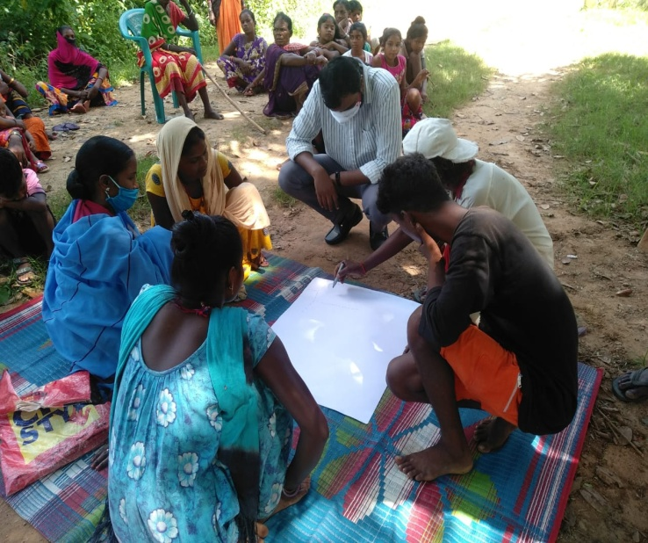
Keeping in view of continuous countrywide lock-down due to spread of COVID-19, and to break the spread of Covid cases, the District administration has suggested to intervene the community mapping directly in the villages by maintaining the safety and social distance. Our Preraks has trained more than 280 Champions in their respective districts to support the Leave No One Behind Approaches in the villages of respective districts. Followings are the active no of champions: Assam: 90, Bihar: 54, Jharkhand: 35, Uttar Pradesh: 18 and West Bengal: 77.
All Preraks had conducted regular community mapping in their respective villages to understand the situation of Leave No one behind Categories and gaps followed by pre-mapping visit and advocating the villagers and stakeholders on how to address those gaps during the gandhigiri and daily validation follow-ups. Preraks are using rapid participatory approaches to gather the details of categories and left our data during the community mapping and encouraging the villagers to come forward with their current situation and challenges then facilitating them to make an action plan to fix those gaps. Next day onwards Gandhigiri is being done by the preraks in the villages of community mapping to validate the data/information. Preraks ware visiting Individual Household and meeting with the family members to understand the actual situation and modifying the detaisl in the maps if required and sharing with the villagers to make and appropriate action plan. Preraks are also demonstrating the low/no cost retrofitting solution and other technological option for improved sanitation facilities.
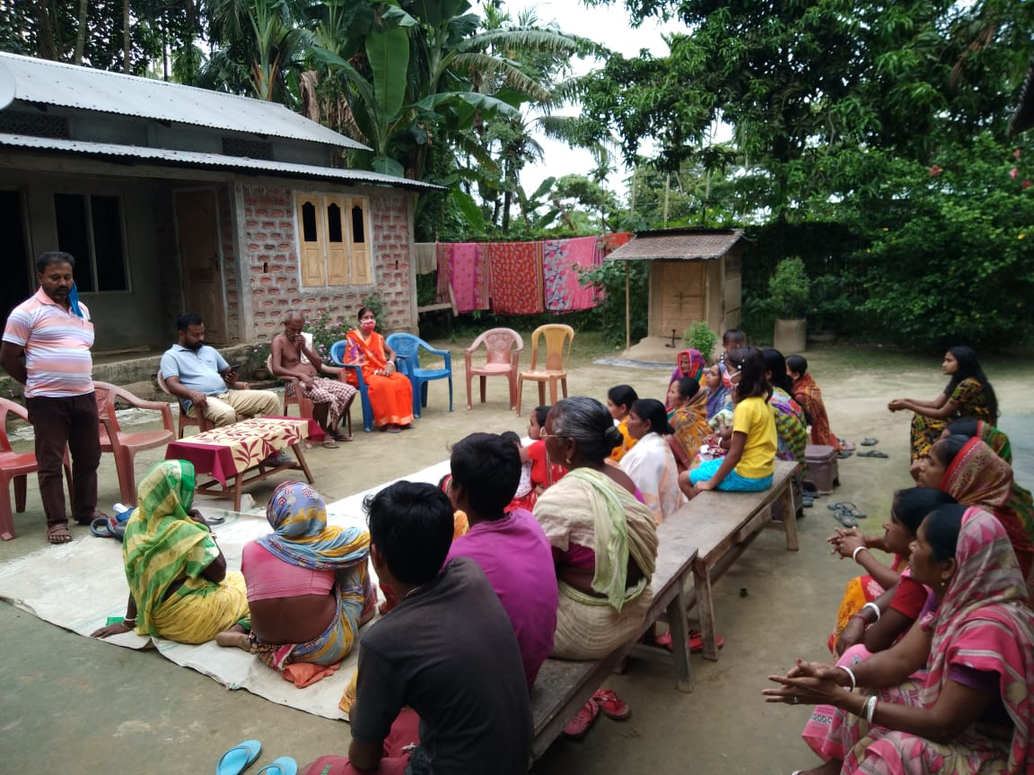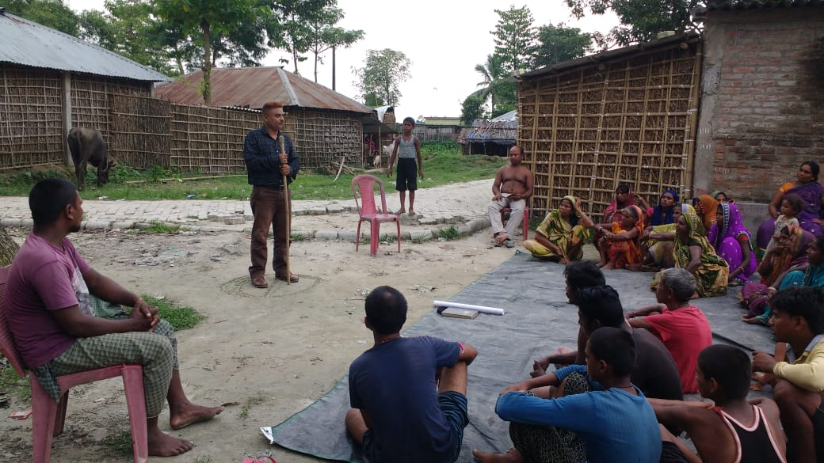

Completion of 04 District level RAL (learning and sharing workshops)
District level Rapid Action Learning workshop has been organised by facilitated by the preraks in kamrup rural and Ranchi for learning and sharing of findings of action research on Community leave no One Behind activities done in the villages. Many participants from District and Block including Executive Engineer, District consultant, block consultant and other stakeholders such as PRI and Champions has joined the online workshop and learned about the activities. The workshop was started by the inaugural speech and background of WSSCC and its support. Preraks has shared the process of Action research and community mapping, challenges, innovations, success stories and suggestion based on their experience from community leave no one behind activities in the villages.
The objective of the workshop was:
- To share action research findings and learn the approaches adopted to ensure No one left behind (CLNOB) for ODF sustainability in the villages
- To review the practical lesion learnt and to integrate the learnings into district specific action plan and in the field implementation
- It is an opportunity for district officials/participants/field functionaries to share their insights, innovations good practice/successful practice, including methods process and approaches developed in the block on SBM-G.

Completion of 2 National one day sharing and learning workshop on LNOB and ODF Plus & Jal Jeevan Mission (JJM)
As requested by the Department of Drinking water and Sanitation at Ministry of Jal Shakti (Government of India) to facilitate the Learning and Sharing Workshop on the occasion of World Toilet Day 2020, WSSCC organized “Sarpanch samwadaurpuruskarsamaroh” and workshop in collaboration with Dept. of Drinking Water & Sanitation on 19th November, 2020 at Ashoka Hotel, New Delhi in presence of Hon’ble Shri Gajendra Singh Shekhawat, MoJS, GoI.
The event witnessed the welcome speech by Shri U. P. Singh, Secretary, MoJS, GoI. During his welcome speech, he highlighted the golden achievement of 100% ODF states while elaborating the challenges that were faced by women due to non-availability of ample number of toilets in the villages. He also kept extra stress on maintaining the ODF status in future as the construction of new houses are continuous process. Capacity building and behavioral changes are the call of time for ODF sustainability. Almost 10.5 cr. Toilets constructed during the Phase I of SBM with period of 2014 to 2019. Now the phase II is moving towards Sanitation sustainability from Complete Sanitation achievement with 5 Golden rules:
- Toilet for All;
- Solid Waste Management;
- Liquid Waste Management;
- GOBAR-dhan; &
- IEC.
Completion of four for drinking and hygiene, nationwide rapidly in short span of time. India Support Unit strongly feels that these videos are better way of learning and sharing through electronic media in this situation. Since the video will be broadcasted on all national channels, this message will reach to nationwide rapidly in short span of time.
Also, 4 sub-National workshopshave been carried over from last year (RAL-2019) and as per request of based on request of Department of Drinking water and Sanitation at Ministry of Jal Shakti (Government of India) to produce the film on Swachh Bharat Mission-G, Phase-II for ODF plus and sustainability. WSSCC has developed twohigh-definitionshort film on “How to make a village ODF, Biodegradable waste management in Rural areas, Non-biodegradable waste management in Rural areas, Grey Water management in rural areas, Faecal sludge Management in rural areas” (https://youtu.be/YPzlbuhXVOg) and “Community Leave No One Behind” (https://youtu.be/y2f0DAUKOjk) The Ministry of Jal Shaktiis disseminating it on social media, digitally and through National Television network.

PROJECT3: GIRL CHILD EDUCATION PROGRAM

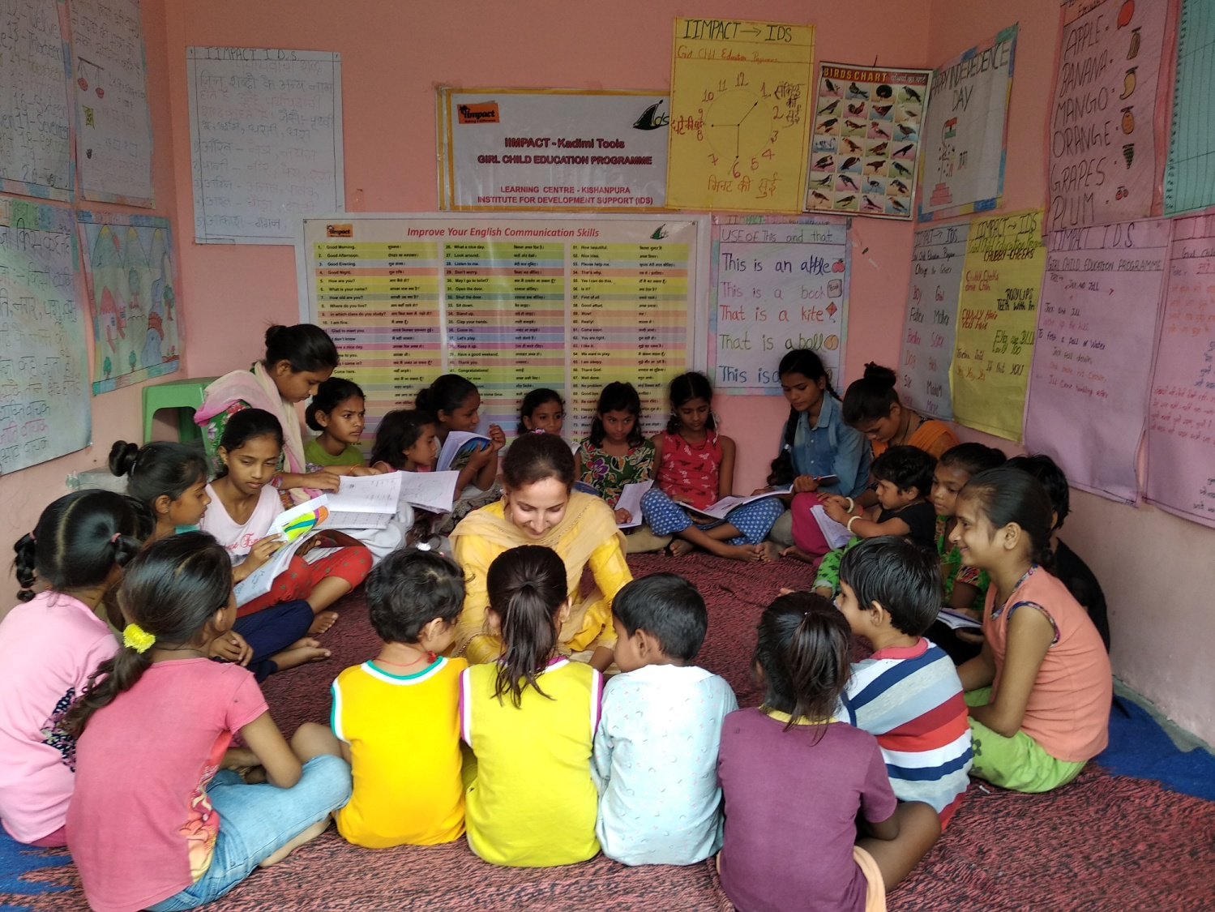
Institute for Development Support with the partnership of IIMPACT is continuously facilitating Girls Child Education Program in the two districts i.e. Dehradun and Uttarkashi district. The program provides free quality educational opportunity to girls aged 6-14 years from socially and economically disadvantaged community of selected area. The objectives of the program are (a) provide meaningful and stimulating education to girls and guide their entry into formal schooling (b) empower and mobilize girls child to become active change agent in their community by helping change society and mind sets around them.

The key activities conducted during the year under the program are described below.

Operation of the Learning Centers
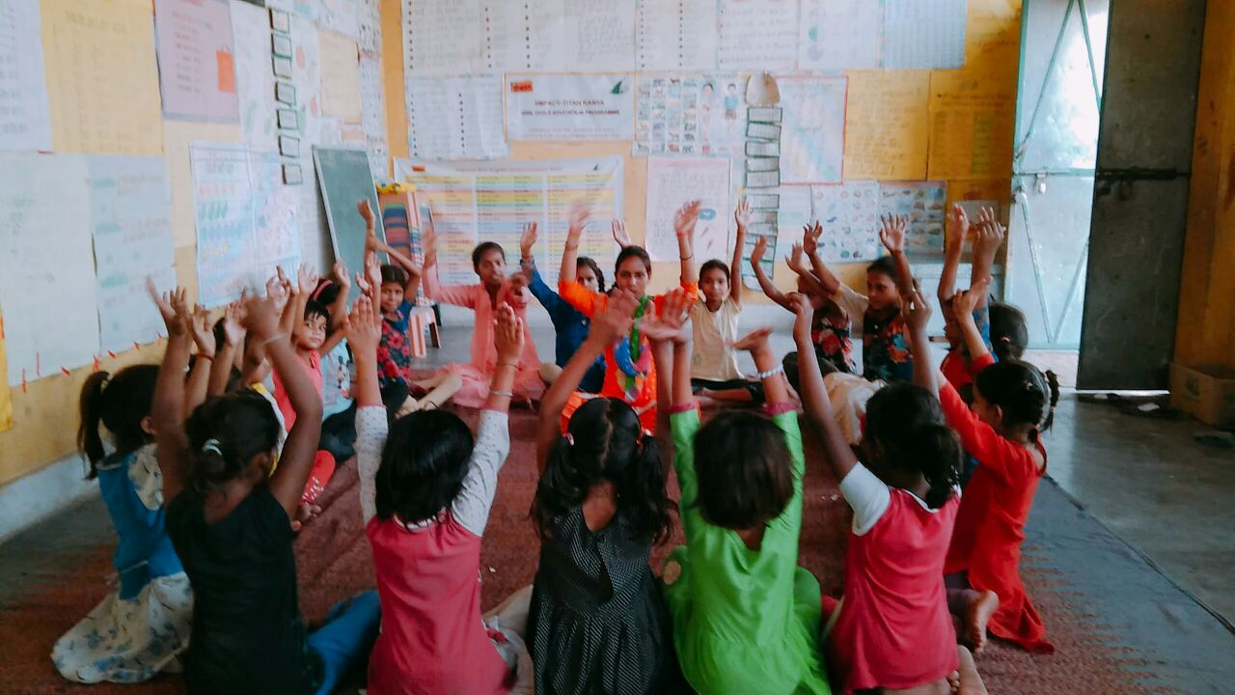
The learning centers are community based located closed to girl's home to facilitate access and to deal with potential parental concerns. The presence of the female teachers also helps them overcome their inhibitions. Each and every center is being operated for 4-5 hours per day. The continuous involvement of the parents in the management of the centers eventually gives total ownership of primary education to the local community which helps in the retention of the girls facilitating continuous learning.

The education model ensures that there is flexibility and adaptability of pace of teaching, teaching methodology, school time table, etc., that suits every out of school girl and no such girl is left out of the program in the project area/villages. The numbers of operational learning centers in both the state are given below.

S.N. | Name of district | No of Learning Center | No of Girl child
1 | Dehradun | 51 | 1530
2 | Uttarkashi | 58 | 1740
 |  | 109 | 3270

Training of Teachers
Teachers are the key to meaningful learning and education selected from local villages itself after well laid down process. An education system succeeds or fails due to quality of its teacher. Therefore, valuing and investment in teachers is a necessity. IDS has conducted quarterly teachers training workshops seeking to improve teacher's subjective knowledge and innovation in teaching skills. The teachers are also trained is issues like health, hygiene, nutrition, and environmental sanitation including preparation of learning material. The no of trainings conducted is given below.

S.N. | Name of district | No of Training | No of participants
1 | Dehradun | 2 | 56
2 | Uttarkashi | 2 | 65
 |  | 4 | 121

Community mobilization and meeting

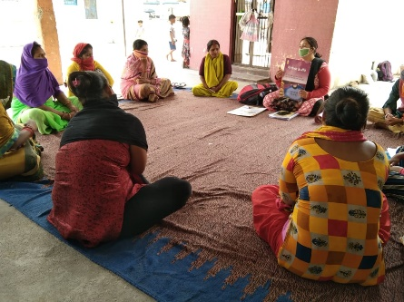
Center Management Committee (CMC) is organized by IDS for the management of each and every learning center. The parents and members of village community are the members of the committee. Interaction meeting with the larger community members is a regular activity to ensure participation in educating girls. The main aim of the meetings is to discuss the academic progress of the children as also attendance issues with the parents. Parents are also provided orientation on various aspects of their children's development. Apart from academic discussion, issues related to child protection, health, nutrition are also discussed so that they can guide their children properly at home to lead a healthy life. The CMC also provides infrastructural support to operate the learning center. The no of CMC meeting are conducted is given below.

S.N. | Name of district | No of meeting | No of participants
1 | Dehradun | 153 | 3060
2 | Uttarkashi | 174 | 4321
 |  | 327 | 7381

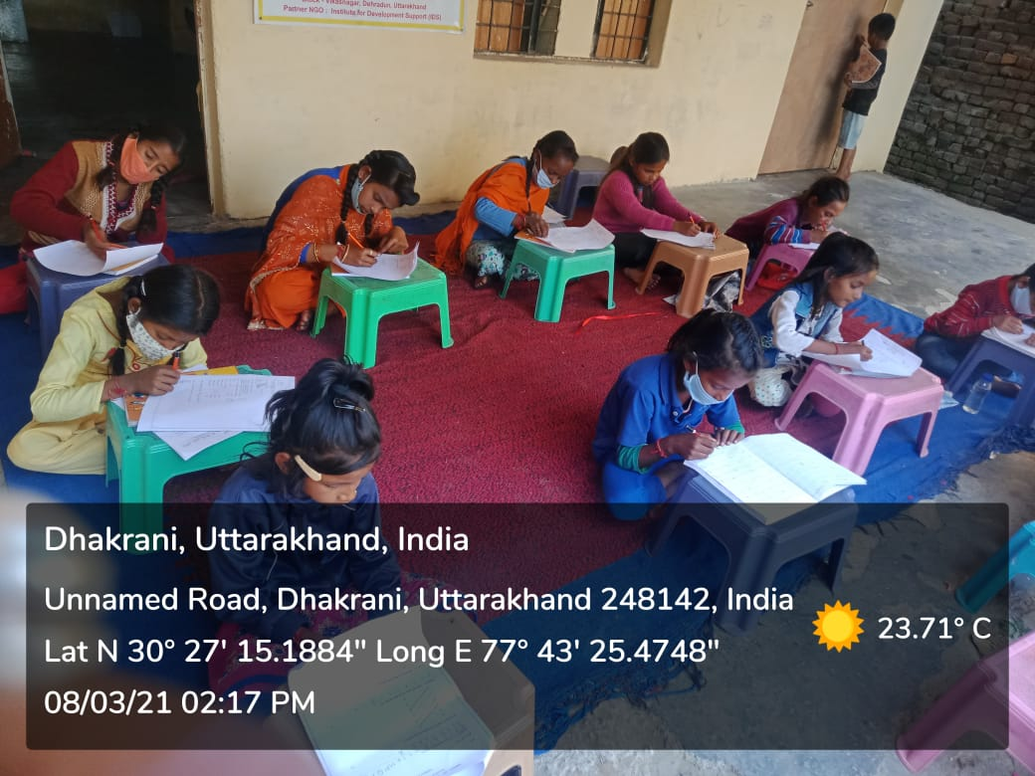
During the unlock down process we started to get permission to promote co- academic activities in the village. We made a batch of 7 and 8 girls of two batches a day and started promoting micro teaching in alternate days in the area. Teachers were instructed to follow the instructions advised in the SOP. They were advised to follow on the social distancing norms, to ensure wearing of masks, and practicing handwashing practicing before and after commencement of the micro teaching sessions. The venue for teaching has been identified other than the learning Centre and no means of learning Centre are utilized during the teaching sessions. Even the girls are advised to bring their own mats, water bottles from their homes. We started the batches only in those areas where we succeeded in getting permission of teaching. We are able to teach the children with around 45-50% of presence of the girls in the micro batches. Proper lesson plan is made by the teachers and same is followed on in the sessions. Due technical assistance is procured by the supervisors, APC and PC during the field visits. However, the number of positive cases of Covid-19 are increasing day by day and there is sense of insecurity against spreading this virus in the area. Hence, stringent Covid-19 protocol is followed on with the adherence of government guidelines. We have advised our field staff if anybody is found positive in the area and they were in the contact with them should be made quarantine at any cost and they should cease any co academic areas in those circumstances. We aimed to encourage the co academic activities in the area so that the process of learning could not be ceased up. In order to make the community connect frequent door to door visits are organized and issues pertaining to the same are discussed during the interpersonal communication.
International Women’s Day celebration in our learning centers
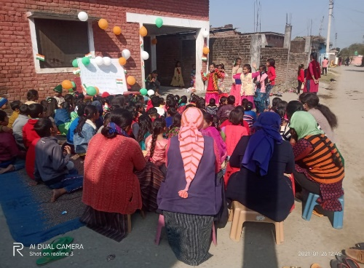
International women’s day was observed on 8 of March, 2021 in all our learning centres. In 1977 United nations recognized the day and declared March 8 as International Women’s Day across the globe. Since then, this event is celebrated to honor the struggle of women and to empower them globally. It is a day to spread awareness among the people regarding women’s rights and gender equality. This day celebrates the social, economic, cultural and political achievements of women. Also, to encourage the women our there that no hurdles can stop them from accomplishing their dream.
This year united nation announced the theme for celebration this mega event was “Women in leadership: Achieving and equal future in Covid-19 world.” The girls of the LCs come forward and did rally cum marchpast to create awareness among the local community. They displayed wooden planks with writing slogans in favor of women folk and their struggle. Teachers of the learning centres informed the girls about the importance of celebrating this day. Apart from this local community were acquainted with the project activities carried out in the vicinity.

