Annual Report 2023-2024

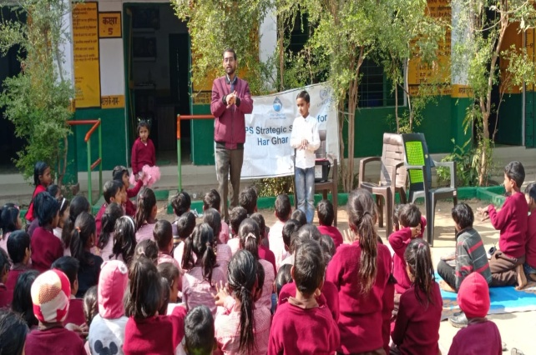

Institute for Development Support (IDS)

Annual Report 2023-2024

A BRIEF PROFILE OF INSTITUTE FOR DEVELOPMENT SUPPORT
Institute for Development Support (I.D.S) is a registered autonomous non-governmental organization, established in 1993-94 and based in Pauri Garhwal, Uttarakahnd. IDS works with rural, urban communities of the Himalayan region with the prime motto of empowerment of the society. The organization believes in an integrated development of Man and Nature and actively involves the stakeholders in implementation of innovative programs in the rural, urban areas of Uttarakhand. IDS mantra is to facilitate mountain communities to know and understand their own strength so that they could participate in the developmental and environmental activities. The organization aims at helping people utilize their inherent potential to improve their well-being through self-awareness and use of traditional wisdom. IDS has multidisciplinary team of professionals including development planners, extension workers and trainers having many years of experience in project development, implementation, capacity building, monitoring and evaluation.

Vision of the organization
To create an empowered and self-reliant society

Mission of the organization
To develop and implement innovative, multidisciplinary developmental programs that are sustainable and replicable.
Objectives of the organization
- To improve socio-economic status of the society.
- To Implement integrated rural development programs for the sustainable development of the society
- To organize capacity building programs for the enhancement of knowledge, skill and entrepreneurship development.
- To create awareness and plan, implement, monitor and evaluate programs related to Education, health, Livelihood, and environment rehabilitation
- To build capacity of community-based organization, women groups and panchayati raj institutions in natural resource management.
- To implement awareness programs for the eradication of various social evils prevailing in the society.
- To introduce various appropriate technologies such as rain water harvesting, biogas, solar energy, composting, solid, liquid waste management, pasture and fodder development, soil-water conservation etc.
- Publication and production of books, magazines, newsletters, posters, films, audios and videos.
Partners
- National Institute of Himalayan Environment, Govt of India
- United Nations office for Project Services (UNOPS)
- Water Supply and Sanitation Collaborative Council, an UN unit
- UNIDO (United nation Industrial Development Organization, Vienna, Austria )
- Integrated Livelihood Support Program-IFAD, Govt of Uttarakhand
- Uttarakhand Tourism Development Board, Govt of Uttarakhand
- WISIONS,Wuppertal Institute for Climate, Environment and Energy, Germany
- IIMPACT, Gurugram Haryana.
- Indo German Energy Program, GIZ, New Delhi
- National Bank for Agriculture and Rural Development (NABARD)
- Forest Department, Government of Uttarakhand
- Jal Sansthan and Jal Nigam, Government of Uttarakhand
- District Administration, Pauri Garhwal
- Health Department, Government of Uttarakhand
- Sir Ratan Tata Trust (SRTT), Mumbai
- District Project Management Unit (DPMU), SWAJAL, Department of Drinking Water, Government of Uttarakhand
- Uttarakhand Renewable Energy Development Agency (UREDA), Government of Uttarakhand
- Shri BhuvneshwariMahila Ashram/ PLAN International
- World Vision, Pauri Garhwal
- Department of Science and Technology, Govt. of India
- Indian Institute of Technology, Roorkee
- CDM Smith Associates Inc. Banglore.
- HIFEED, Ranichounri, Tehri Garhwal
- M/S Karvy Pvt Ltd
- Centre for Environmental Education, Lucknow
- IT Power synergy services Ltd, Gurgoan
- Department of Planning and Statistics, GoUK
- IL&FS Pvt. Limited, New Delhi

Institute for Development Support is working in more than 400 villages of Uttarakhand, Himachal, Assam, Rajasthan, and UP in the following areas.
- Economic empowerment: The program focuses on promoting agriculture and horticulture-based livelihoods for the local community. It also provides training, capacity building, and vocational training to youth on various livelihood options.
In addition, the program aims to establish community-based microfinance groups and women Self-Help Groups (SHGs) engaged in micro-enterprises to enhance their livelihoods.
Several trainings and capacity-building programs were organized on topics such as vegetable farming, beekeeping, dairy development, spices cultivation, mushroom farming, fruit processing, nursery development, poultry farming, marketing of products, and non-farm activities including recycling of waste materials and development of value-added products in rural and urban areas.
- Community Based Tourism: IDS has been engaged in planning, implementation, monitoring and supervision of community-based tourism activities in Uttarakhand for livelihood enhancement. The key activities being performed under the projects are identification of suitable villages for tourism development, IEC, formation and management of village tourism development committee, eco development committee, identification of their training need, designining and implementation of training in hospitability management, cooking, bird watching, interpretation, nature guiding, low cost dwelling units, business plan preparation, linkages with parytan swarojgar yojna and established linkages with marketing agencies.
- Water & Environment Sanitation: IDS has facilitated planning and implementation of many rural water and environmental sanitation schemes in the villages of Uttarakhand, UP, Assam, Rajasthan and West Bengal supported Govt and internation organizations under Sector Wide Approach and total sanitation campaign. IDS empowered community-based organization particularly village water and sanitation committees to execute safe water supply and sanitation program for sustainable health and hygiene. An innovative, solar lifting water scheme and rain water harvesting schemes were also plan and implemented to fulfil the need and demand of the villagers. Apart from this, IDS is facilitating construction of household sanitary toilets, school sanitation, environmental sanitation and menstrual hygiene management. IDS has implemented Rapid Action Learning and Menstrual Hygiene management program under Swachh Bharat Mission supported by WSSCC, a UN organization. Recently, IDS has successfully completed Provision of capacity building management and support for the implementation of Jal Jeevan Mission (Rural Water Supply Program) supported by UNOPS.
- Gender Empowerment: Under this program, the organization is generating awareness among community members, PRIs, women groups, government officials/institutions, children groups on gender equity and equality. Capacity building training of youth & women on different issues/skills, government law & policies are also the part of the program.
- Renewable energy for livelihood development: Organization is engaged in implementation of programs that promote clean, green renewable energy to mitigate the adverse impact of climate change. To generate awareness among community members about green energy, IDS has organized several Green techno fairs or exhibition in Uttarakhand. Traditionally watermills have been source of clean energy and mechanical power to grind food grains in Uttarakhand. IDS has also been engaged in installation of model water mill and improvement of traditional water mill for electricity generation as well. The local communities residing nearby the watermill were organized into SHGs for the processing, packaging marketing of watermill processed products for livelihood enhancement.
- Education & Health Program: IDS is regularly involved into improvement in formal and informal education program with communities. Organization operating 164 Girl Child Education Centre for the girl child who could not attended formal schooling or drop out from the school in Dehradun, Himachal and Mori, Purola and Naogaon Block of Uttarakashi. Apart from this IDS also promoted eco clubs in the 150 school for imparting better environmental education to children. Child right is another key area where organization has organized many advocacy programs. IDS implemented reproductive child health program that include preparation of birth plans, educating & mobilizing mothers for early registration, complete vaccination, IFA distribution, institution delivery and other health & hygiene issues. In addition to this the program is also focused to educate adolescents on reproductive & sexual health, conducted of health camps in remote area, regular school level camps, regular counseling, eradication of female foeticide and treatment of mal-nourished children etc.
- Natural Resource management
The economy of Uttarakhand is more dependent on natural resources. The condition of the natural resources is deteriorating day by day. Considering the facts, IDS have been regularly engaged in conservation and protection of natural resource through community institution such as van panchayats, PRI, SHGs and Mahila Mangal Dals. The key program organized under the components are formation and strengthening of van panchayats, imparted different capacity building trainings to committee members and villagers, supported to committee members for nursery development, plantation, trenching, construction of ponds and rain water harvesting tanks.

Management structure
The executive board of the IDS is apex body which provides guidance and takes final decision regarding growth of the institution. The Executive Director nominated by the apex body is responsible for the implementation of the decision taken by the board. Executive Director provides guidance and assistance to staff, project team and field facilitator for effective planning and implementation of the programs. IDS has separate Project Coordinator or Team Leader and experts for the projects being implemented by the IDS.
Executive Body
Executive Director
Program Coordinator

Program Coordinator
Program Coordinator

Field Facilitators

Field Facilitators

Field Facilitators

Admin &Finance Officer

Subject specialist

Summary of projects Activities carried out by Institute for Development Support during 2023-24

S.N. | Project name/ Place | Beneficiary | Funding from
1 | Provision of capacity building management and support for the implementation of Jal Jeevan Mission (Rural Water Supply Program): Uttar Pradesh_Phase-II | Rural community of UP | United Nations Office for Project Services (UNOPS)
2 | Provision of capacity building management and support for the implementation of Jal Jeevan Mission (Rural Water Supply Program): Assam | Rural community of Assam | United Nations Office for Project Services (UNOPS)
3 | Provision of capacity building management and support for the implementation of Jal Jeevan Mission (Rural Water Supply Program): Rajasthan | Rural community of Rajasthan | United Nations Office for Project Services (UNOPS)
4 | Girls Child Education Program | 35 villages of Dehradun and 45 villages of Mori , 30 villages of Naugoan, Purola block of Uttarkashi and 15 villages of Paonta Sahib, HP | IIMPACT, Gurugram, Haryana

PROJECT-1 Provision of capacity building management and support for the implementation of Jal Jeevan Mission (Rural Water Supply Program): Uttar Pradesh_Phase-II
Following activities have been conducted by IDS during reporting period.
- Review the on ground progress of FHTC work
The state and district teams are working intensively to achieve the target of 100% FHTC as soon as possible. To fulfill this objective, district team is now also looking at the cooperation of UNOPS team in their respective districts. Under this, the district coordinators of UNOPS conducted a detailed survey of their intervention villages in the month of January and collected the data of the missing houses and submitted it to the executive engineers. Its objective is to ensure 100 percent water connection to all the houses in all the villages falling under the jurisdiction of UNOPS.
As a result of this, so far 36 out of 137 UNOPS villages have been covered under the Har Ghar Jal Yojana i.e. 100% FHTC at every household.
- Refresher training on Operation & Maintenance (O&M):
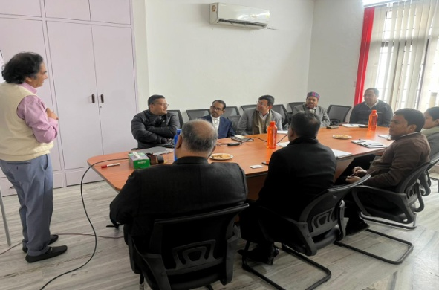
The refresher training for Operation and Maintenance (O&M) held in all intervention villages of Sonbhadra district. The purpose of the activity was to reiterate the O&M triggering tools and to prepare draft bylaws with support of community members. During the activity discussion was done on the following –
- O&M budgeting: the exercise to list down the items of expenditure for O&M and its estimated costing in particular village.
- Agreed lead time analysis: the exercise to list out the expected items for maintenance & expected time to make it functional.
- Misuse and Saving of Water: the exercise to identify the possible practice of both misuse & saving of water and its penalty & Incentive.

Support provided at State and District level
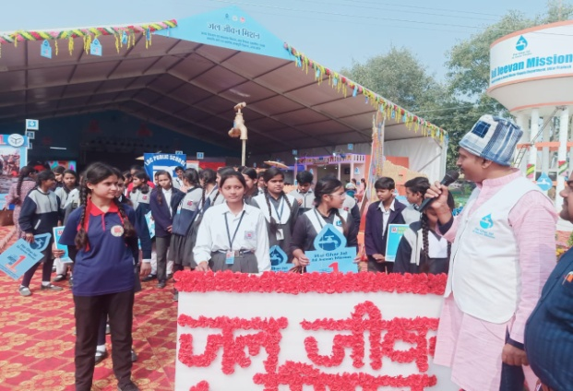
      - State Consultant attended round table discussion on “Community Managed Water Supply Schemes” organized by Tata Trust on 12th January. During the meeting developmental partners from 8 organizations i.e. UNICEF, UNOPS, Aga Khan Foundation, SIRD etc brainstormed and shared their views & practices existing in the respective field area. The meeting was held in Tata trust office at Gomti Nagar, Lucknow.
Round table discussion on Community managed water supply schemes
      - Based on the ask received from DDWS NJJM on shooting of 52 episode Travelogue series on JJM & SBM-G in different states, UNOPS State Coordinator has been appointed as nodal from SWSM, UP to facilitate the 5 days shoot in Mahoba district in Kaneri & Lilwahi villages. The purpose of the activity was to capture the story of achieving ‘Har Ghar Jal’ status and successful efforts being made to keep it sustainable. The letters related to the same is enclosed as annexure.
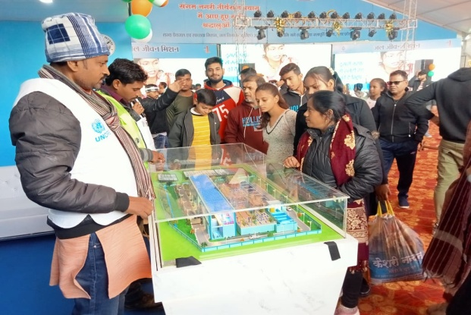
      - Participated in Action Plan preparation meeting held in Delhi on 17-18th January 2024. During the meeting discussion was done on VWSC training module, RAL, Action plan, model village indicators, state activities, exposure visit etc.
      - As a state nodal officer for Viksit Bharat Sankalp Yatra, State Consultant UNOPS attended virtual VBSY review meeting organized by NJJM held on 10th January. The meeting was chaired by secretary DDWS. During the meeting status of uploading of Abhinandan patra has been discussed.
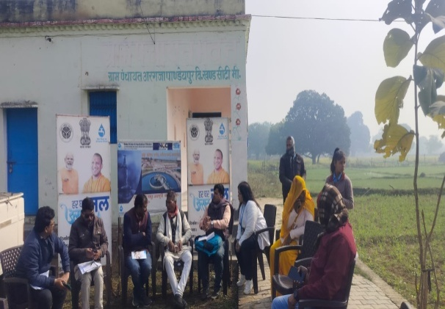
      - As a nodal officer to coordinate with empanelled IEC agencies in the state, SC UNOPS participated in the review meeting held at SWSM office on 8th January with all 13 empanelled agencies. The meeting was cheered by Executive Director & Senior Media Consultant nad reviewed the portal based progress of the activities.
      - Based on the request letter received from State Water and Sanitation Mission (SWSM), DC Kaushambi and Prayagraj participated and facilitated the Magh Mela in Prayagraj district. During the activity both DCs addressed the visitors i.e. government officials, community members, school children & youth and informed about the Jal Jeevan Mission. They also sensitized children about their role as change maker in the society especially for conservation of water. Different infotainment activities were also performed to create awareness on water safety, security under JJM.
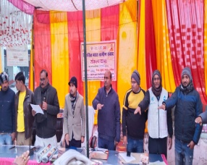
Copy of the office order is enclosed in annexure.
      - DC Mirzapur participated in Har Ghar Certifiation ceremony organized at one of the UNOPS intervention village Argja Pandeypur on 12th January. During the activity 52 community members were registered their active participation and Village Pradhan was given an Abhinandan Patra.
Har Ghar Jal certification is a process which is organized by the Jal Nigam after ensuring the 100% FHTC connection at every household of the Gram Panchayat. During the process Gram Pradhan along with the community members declare that the village is saturated with tap connection. A written certification is also given by the Gram Pradhan to Jal Nigam.
      - Viksit Bharat Sankalp Yatra: On behalf of SWSM, State Consultant, UNOPS supervising the Viksit Bharat Sankalp Yatra in the state with the Department of Drinking Water & Sanitation (DDWS). The purpose of the activity is to create awareness on various government schemes including HGJ. During the activity Gram pradhans of Hra Ghar Jal reported Gram Panchayats are being provided 'Har Ghar Jal Abhinandan Patra' by district level officials. Beneficiaries of various schemes are also sharing their story of change "Meri Kahani Meri Zubani" during the activity.
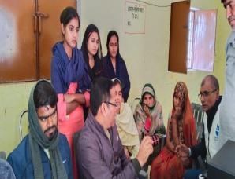
District Coordinators from UNOPS participated in the event and facilitated the event while creating awareness on HGJ pariyojana in the intervention districts.
      - DC Hamirpur facilitated the session on Water Quality Testing and uploading of report on WQMIS portal in Mancha & Kanuta Danda village (other than UNOPS intervention villages) with FTK trained women. The activity was performed based on the request received from Executive Engineer Hamirpur. Another purpose of the activity was to provide hands-on knowledge on water quality testing to the women group.
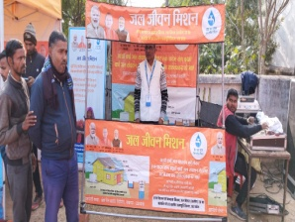
      - Based on the request received from the district administration DC Hamirpur participated in the activity organized at Kanauta Danda village, where State Jal Shakti Minister Mr. Swatantra Dev Singh felicitated the performers of Jal Jeevan Mission. During the activity UNOPS DC had played the role of facilitator for demonstration of water quality testing & use of FTK.

- Visit of Senior Advisor, Programme and Partnerships, Asia region-Bangkok in district Jhansi.
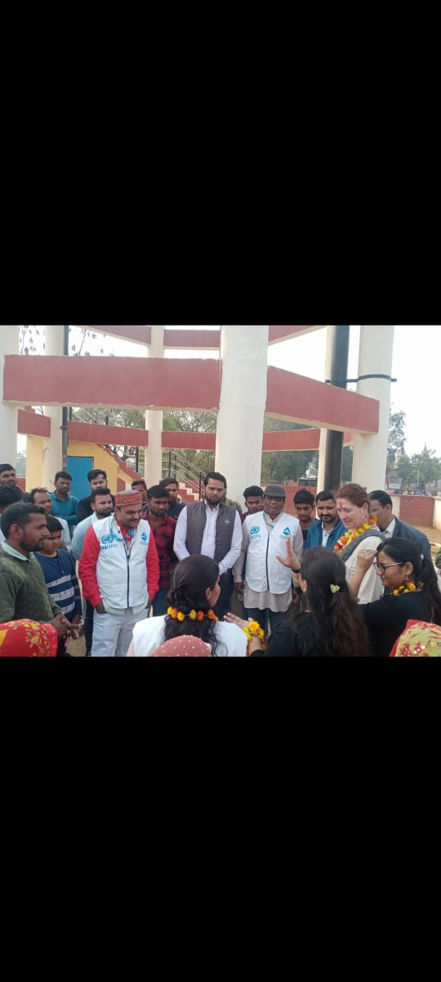
Senior Advisor, Programme and Partnerships, Asia region-Bangkok Ms. Simonetta Siligato visited WASH project village Imliya in Jhansi district of Uttar Pradesh. The purpose of the visit is to understand the type of support UNOPS is extending under the Jal Jeevan Mission program in UP. During the visit she interacted with VWSC members & FTK trained women and understood their role under JJM. She also become familiar with UNOPS community based interactive tools i.e. CLNOB & O&M triggering tool. Demonstration of use of Field Testing Kit was also done by the FTK trained Women.
Following her community visit, she also had interaction with District Magistrate Jhansi, Chief Engineer and Executive Engineer of Jal Nigam to understand the government role for achieving JJM objectives.
Ms. Simonetta at OHT in one of the intervention village
- Project Midterm Review in Uttar Pradesh
In continuation of the Mid Term Project Review, the review team reached Uttar Pradesh on 27-28 August and met the state level officials (Executive Director & Senior Media Consultant of State Water and Sanitation Mission), State Consultant, district consultant (Banda) of UNOPS and district officials (District Magistate, ADM Namami Gange, Executive engineer, etc) to know and understand the work of UNOPS in respective districts.
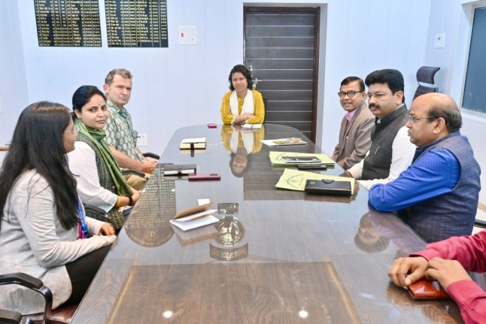
The team of reviewers mainly includes Mr. Claes Clifford, Mass. Ginisha and Nicholai were present from Denmark Embassy. The team also visited Barokhar Khurd village of Banda district (one of the UNOPS intervention village) and understood and appreciated the work being done by UNOPS at the grassroots level in past 2 and half year. During the meeting with the DM of Banda district, the review team also learned about the work being done on water by the Jal Jeevan Mission team in the district.
Meeting with DM, Banda

Activities in Assam

Activity 1: Paani Panchayat – Community analyses of water demand and availability
Paani Panchayat is a triggering participatory exercise to raise community awareness on access to piped water, water conservation, and sustaining traditional water sources at the household and community levels – by making the community realize the average time spent on water-related activities and the demand and availability of water in the community.
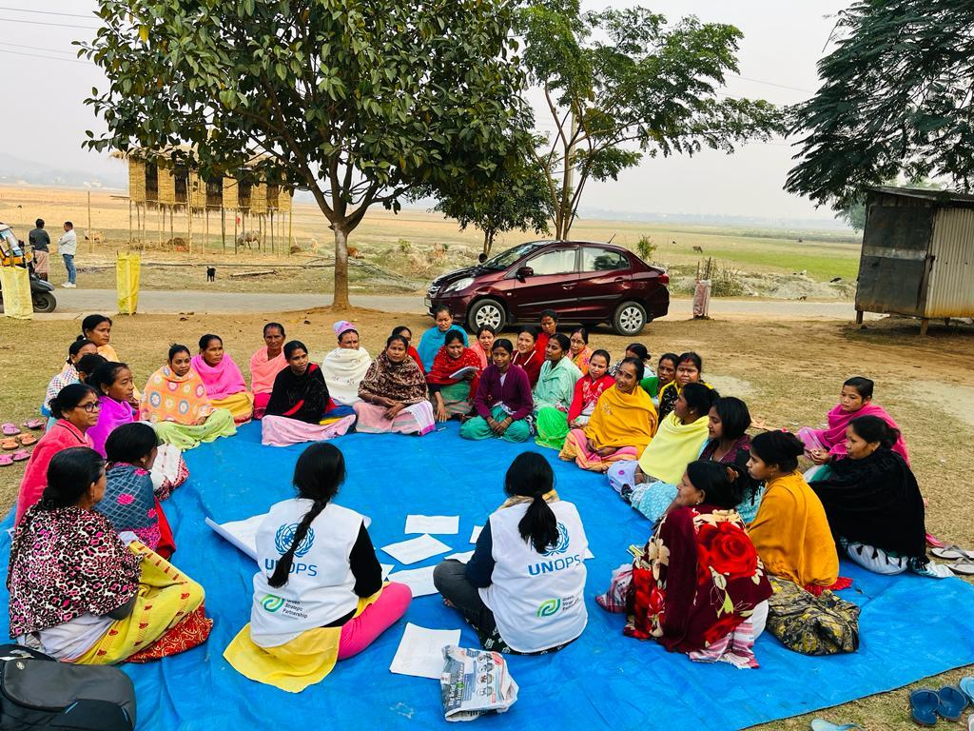
Image 1: UNOPS CDCs in Kamrup facilitating Paani Panchayat in Sanpara Parbat village
Women, as the primary users and managers of water at both household and community levels, were the primary participants of this exercise. The Paani panchayat comprises three community-led analyses of water usage, water demands, and water availability.
- Women's time use analysis aims to develop a collective realization among the community on the time being spent every day on fetching and managing water for daily household requirements – sensitizing the community on how piped water under the JJM would reduce the time spent for water fetching and management.
- Water use analysis aims to develop a comprehensive understanding among the community on the amount of water an individual/ a household/ a community spends every day on different activities – triggering a realization among the community on rational usage of water and saving water,
- Water budgeting aims to estimate the water requirements at the household/ community levels and the availability of water against those demands – promoting community planning and action for water conservation and sustaining traditional/ natural water sources in the community.
As facilitated by UNOPS field teams, all these analyses were performed by the community. The primary purposes of the Paani panchayat are to:
- Create community awareness on water conservation and source sustainability,
- Increase demands for the piped water under the Jal Jeevan Mission.

Activity 2: Hand-holding support for the FTK women groups in intervention villages
Following the direction of the divisional offices of the PHED, UNOPS field teams in both Kamrup and Nalbari districts extended follow-up hand-holding supports for the villagewise FTK women groups, so that the women group regularly conducts water quality tests using the FTK and timely submits the reports of the same.
UNOPS team/s monitored and supervised the FTK women groups and the regularity of them conducting water quality tests using the FTK and reporting the results to the WQMIS portal, as well as addressed any difficulties the women group might have had, to get them fluent with the processes.

Activity 3: Community meeting on 100% FHTC following DPR revision
Based on the findings of the CLNOB exercise, a community-led situational analysis of the status and the community needs in the aspects of access, usage, and management of water, UNOPS facilitated the preparation of the Village Action Plan, which were approved by the Gram Sabha through special Gram Sabha. The VAPs contained provisions for improving community access of safe water according to the identified needs.
UNOPS engaged in constructive discussions and advocacy with concerned PHED offices for reaching out to the left-out households with piped water. Upon reviewing the findings of the CLNOB exercise, PHED directed the DPR agency to revise the exisiting DPRs and include all households that were initially left-out of piped water supply connections. The DPR agency, with support from UNOPS field team in Nalbari, carried out geospatial mapping of left-out households and proceeded revising the DPRs. The DPR revision included 431 left-out households in 6 villages.

Activity 4: Meeting with Gram Panchayat, Block Development office, and Zila Parishad to advocate the inclusion of provision of approved VAPs into the GPDP
UNOPS facilitated the preparation of Village Action Plans (VAPs) in its intervention villages, which were later accepted and approved by the concerned gram panchayats by convening special gram sabhas. Though the VAPs were ratified and accepted by gram panchayats, all the provisions proposed in the VAPs are required to be incorporated in the Gram Panchayat Development Plan (GPDP), prepared annually, to ensure actions, interventions, and measures to adequately address the community needs as outlined in the VAPs.
For this purpose, UNOPS field teams carried out extensive advocacies at different levels. UNOPS field teams held rounds of discussions with the CEO, Deputy CEO of the Zila Parishad, Block Development Officer, Assistant Block Development Officer, Gram Panchayat Coordinator, and the concerned officials and functionaries of the gram panchayats including the president and secretary. The process involved familiarizing these stakeholders with the process of preparing the VAPs as well as the gaps and needs identified by the communities as facilitated by UNOPS and outlined in the VAPs.
The gram panchayats in UNOPS intervention areas have not started preparing the GPDP yet, however, all the concerned authorities/ departments/ officials/ and functionaries have assured UNOPS field teams of incorporating the provisions proposed in the VAPs into the GPDP as and when it is prepared.

Activity 5: Facilitating periodic meetings of Water User Committees (WUCs) and recording minutes of such meetings
Water User Committees (WUCs), beneficiary-led committees formed under the jurisdiction of the gram panchayat are responsible for the operation and maintenance of the piped water supply schemes in their respective villages. Previously, UNOPS field teams facilitated the formation of WUCs in UNOPS-supported villages.
In the month of February 2024, UNOPS field teams followed up with WUCs in UNOPS-supported villages and facilitated the convening of periodic meetings of the WUCs, which is required under the guideline, and facilitated the recording of minutes of the meetings. As facilitated by UNOPS field teams, the WUCs carried out discussions on different aspects of operating and maintaining the water supply scheme, such as regularity and frequency of water supply, functionality of the pipeline, coverage of the scheme, requirements of works for ensuring efficient functioning of the scheme, and any and all grievances that the beneficiaries have had. The minutes of these meetings were duly recorded by the WUCs.
In this period, UNOPS field teams facilitated the convening of periodic meetings and recording minutes of WUCs in the following UNOPS-supported villages: Katuriya, Bhanukuchi, Niz-Khagta, KunderganJaberihati, Burburi, Chenikuchi, Kathora, and Borigaon.

Activity 6: Accompanying District team on verification of left-out households and habitations for DPR inclusion
As an outcome of various participatory activities facilitated by UNOPS, such as CLNOB, VAP preparation etc. as well as constant advocacies for 100% FHTCs, the Nalbari division of the PHED, Assam ordered revising the DPRs to include 431 households in six villages that were initially left-out of piped water supply.
The District Commissioner, Nalbari set up a committee to verify the left-out status of these households through field verification. The committee was led by the Circle Officer. The circle officer led committee visited each of the six villages, and held one-to-one interactions with the left-out households.
The UNOPS field team in Nalbari accompanied the verification team and facilitated their visit. Based on the findings from the visit, the verification team submitted its report to the district commissioner, Nalbari. Upon this, the District Commissioner, Nalbari approved the revision of the DPR, which ensured piped water supply to these left-out households.
Project activities in Rajasthan

ACTIVITY-1: RECONSTITUTION OF VWSC IN VILLAGES
The Village Water and Sanitation Committees (VWSCs), sub-committees of the Gram Panchayats, are the key implementing body in the villages, which are bestowed the ultimate responsibility of ensuring water quality of prescribed standards delivered to all households and village institutions, ensure effective tariff collection from the households and thus managing the O&M of the in-village water supply schemes, for the designed period.
During the previous month, further to the participatory process of formulation of the Village Action Plans in consultation of the PRI members, earlier formed VWSC, field functionaries viz. ASHA, ANM, Anganwadi workers and other community members, the task of reconstitution was accomplished in the project villages of Shahpura block, Jaipur rural District; Viratnagar block of Jaipur rural District and the Badgaon block of Udaipur District.
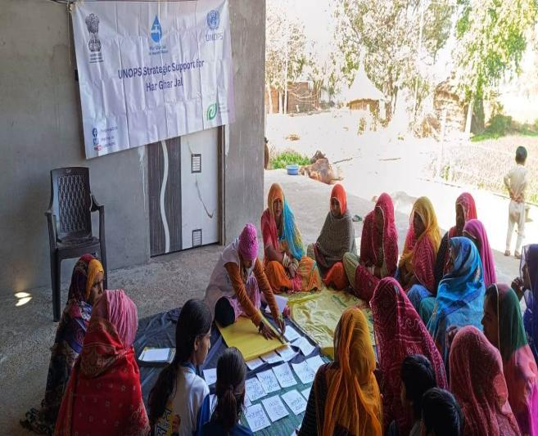
The table displays the number of VWSSCs reconstituted in the project villages in the Districts/ Blocks under UNOPS’ support for the effective implementation of the JalJeevan Mission.

ACTIVITY-2: PANI PANCHAYAT
The Pani Panchayat activity focuses on three main objectives as under:
- Gender sensitive approach towards water management by conducting women’s time use analysis activity whereby the men folk are sensitized towards the time and energy spent by women for managing different household chores as well as for fetching and utilizing water for drinking and other domestic usages.
- Water Use analysis focusing on the different water sources available within the village and their usage for drinking and other domestic usages, whereby the communities n take decisions for securing the sources primarily used for drinking purposes.
- Water budgeting exercise, which focuses on carrying out estimation of the water availability through rainfall Vs the demand for irrigation based on the cropping pattern; whereby the communities can take decisions for water conservation vis-à-vis cropping pattern depending upon the rainfall in their area.
The Pani Panchayat activity was yet to be conducted in all the 12 revenue villages under the 3 GPs of Viratnagar block. The District Consultant0Viratngar block, initially in collaboration with the District Consultant-Shahpura conducted the Pani Panchayat activity in 2 villagesviz. Govindpuradhabaiand Dholikothi villages and then conducted the Pani Panchayat activity in the rest 10 villages of the Viratnagar block.

ACTIVITY-3: CONDUCTION OF COMMUNITY LED ASSESSMENT OF SANITARY SURVEY (CLASS)
Community led Assessment of Sanitary Survey (CLASS) activity focuses on the awareness of the village communities on the Disease surveillance which occurs due to bacteriological contamination, which again is in turn due to the unhygienic environment in the villages due to littering, lack of solid and liquid waste management measures at the household or the community level. The exercise furthermore emphasizes on the regular water quality monitoring & surveillance by the community, especially by selected women members of the community as prescribed in the Guidelines of the JalJeevan Mission.
CLASS activity was conducted in 8 villages namely Surpura, Dholikothi, Leeloka bas, Dhobiyawali, Gurjarpura, Chatarpura, Jawanpuradhabai and Neejharof the Viratnagar block of Jaipur rural district

ACTIVITY 4: CONVERGENCE OF THE VAP WITH GPDP
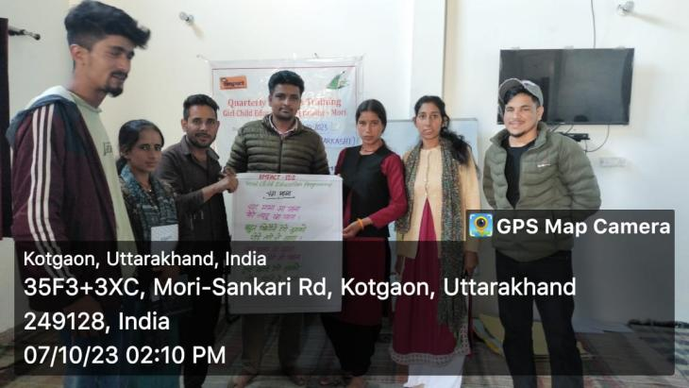The model Village Action Plan is the comprehensive document prepared by the District Consultants in consultation with the VWSCs, the PRI members, village functionaries and the village community members, which focuses on the activities related to (i) drinking water supply infrastructure; (ii) source strengthening; (iii) grey water management options for every household; (iv) O&M mechanisms and tariff collection and (v) water quality monitoring & surveillance. The JalJeevan Mission program would provide financial assistance for the development of the drinking water supply infrastructure while the other activities as encompassed in the Village Action Plan are to be taken up through financial assistance from convergence of different other programs viz. SBM(G), MNREGS, XVth Finance Commission, MPLAD, MLALAD etc. For the purpose of availing the financial assistance from other government programs/ schemes, the VAPs have to be converged with the Gram Panchayat Development Plan.
PROJECT4: GIRL CHILD EDUCATION PROGRAM

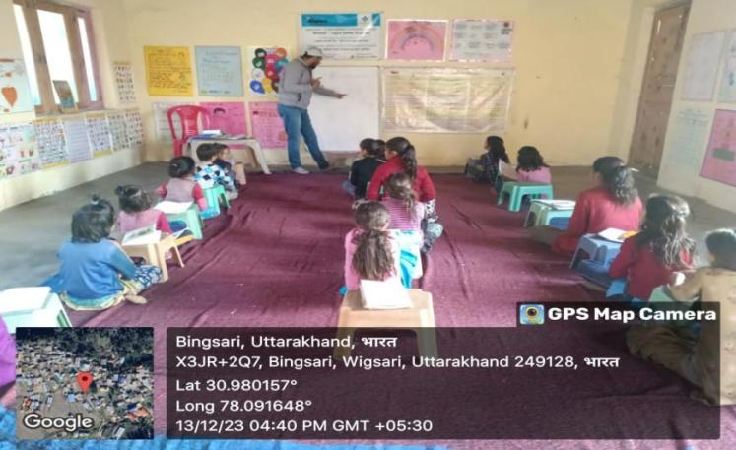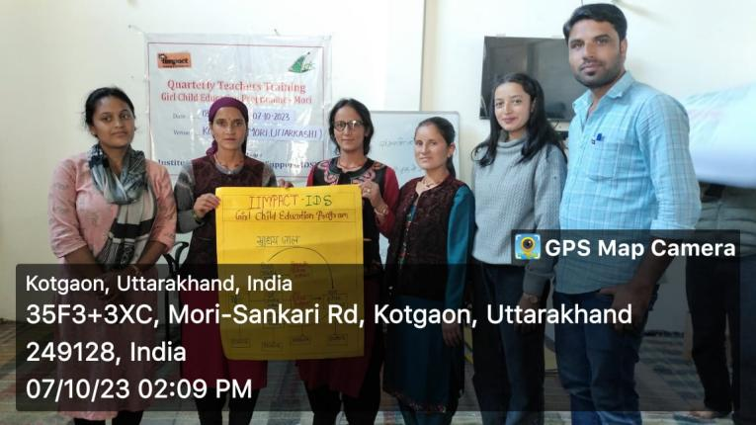Institute for Development Support with the partnership of IIMPACT is continuously facilitating Girls Child Education Program in the districts i.e. Dehradun, Uttarkashi district and Himachal Pradesh. The program provides free quality educational opportunity to girls aged 6-14 years from socially and economically disadvantaged community of selected area. The objectives of the program are (a) provide meaningful and stimulating education to girls and guide their entry into formal schooling (b) empower and mobilize girls child to become active change agent in their community by helping change society and mind sets around them.

The key activities conducted during the year under the program are described below.
Operation of the Learning Centers
The learning centers are community based located closed to girl's home to facilitate access and to deal with potential parental concerns. The presence of the female teachers also helps them overcome their inhibitions. Each and every center is being operated for 4-5 hours per day. The continuous involvement of the parents in the management of the centers eventually gives total ownership of primary education to the local community which helps in the retention of the girls facilitating continuous learning.
Classrooms Sessions, LC – Wigsari, LC-02500

The education model ensures that there is flexibility and adaptability of pace of teaching, teaching methodology, school time table, etc., that suits every out of school girl and no such girl is left out of the program in the project area/villages. The numbers of operational learning centers in both the state are given below.

S.N. | Name of district | No of Learning Center | No of Girl child
1 | Doiwala, Sahaspur and Vikasnagar block of Dehradun | 51 | 1530
2 | Mori Block, Uttarkashi | 58 | 1740
3 | Naugoan and Purola block of Uttarkashi | 40 | 1175
4 | Paonta sahib block of Himachal Pradesh | 15 | 438
 | Total | 164 | 4883

Training of Teachers
Teachers are the key to meaningful learning and education selected from local villages itself after well laid down process. An education system succeeds or fails due to quality of its teacher. Therefore, valuing and investment in teachers is a necessity. IDS has conducted quarterly teachers training workshops seeking to improve teacher's subjective knowledge and innovation in teaching skills. The teachers are also trained is issues like health, hygiene, nutrition, and environmental sanitation including preparation of learning material. The no of trainings conducted is given below.

S.N. | Name of district | No of Training | No of participants
1 | Doiwala, Sahaspur and Vikasnagar block of Dehradun | 4 | 198
2 | Mori Block, Uttarkashi | 4 | 240
3 | Naugoan and Purola block of Uttarkashi | 4 | 155
4 | Paonta sahib block of Himachal Pradesh | 4 | 58
 |  | 16 | 651

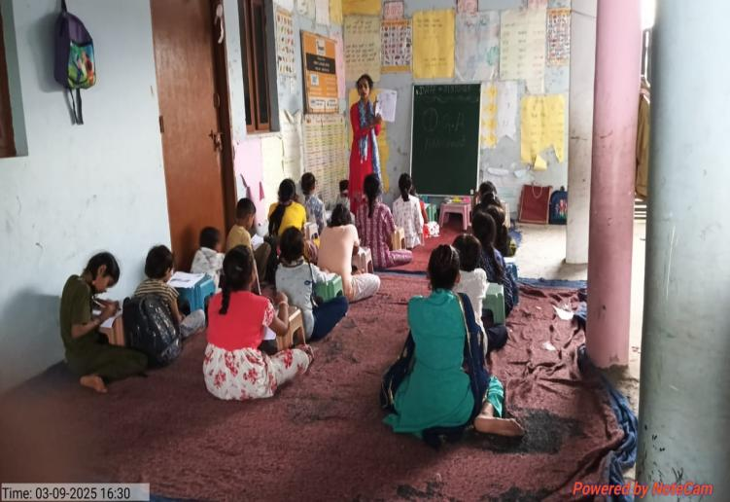
- The training's are now given by the PNGO itself so we have tried to take the topics which have never covered or in which teachers need more input, so the agenda was made according to the inputs given by the academic facilitators and teachers themselves.
- 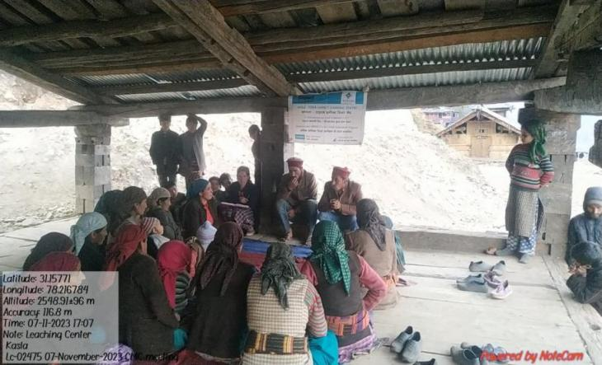We have invited some external trainers from different expertise to provide some more information to our teachers. They have conducted session of female reproductive health, Hygiene during menstruation, and consultation to the adolescent girls who are in need to know such hygiene practices, community engagement etc.
CMC, LC- Kasla ( LC-02475)

Community mobilization and meeting

Center Management Committee (CMC) is organized by IDS for the management of each and every learning center. The parents and members of village community are the members of the committee. Interaction meeting with the larger community members is a regular activity to ensure participation in educating girls. The main aim of the meetings is to discuss the academic progress of the children as also attendance issues with the parents. Parents are also provided orientation on various aspects of their children's development. Apart from academic discussion, issues related to child protection, health, nutrition are also discussed so that they can guide their children properly at home to lead a healthy life. The CMC also provides infrastructural support to operate the learning center. The no of CMC meeting are conducted is given below.

S.N. | Name of district | No of meeting | No of participants
1 | Doiwala, Sahaspur and Vikasnagar block of Dehradun | 220 | 4506
2 | Mori Block, Uttarkashi | 250 | 4816
3 | Naugoan and Purola block of Uttarkashi | 150 | 2250
4 | Paonta sahib block of Himachal Pradesh | 60 | 1080
 | Total | 680 | 12652
Highlights of year

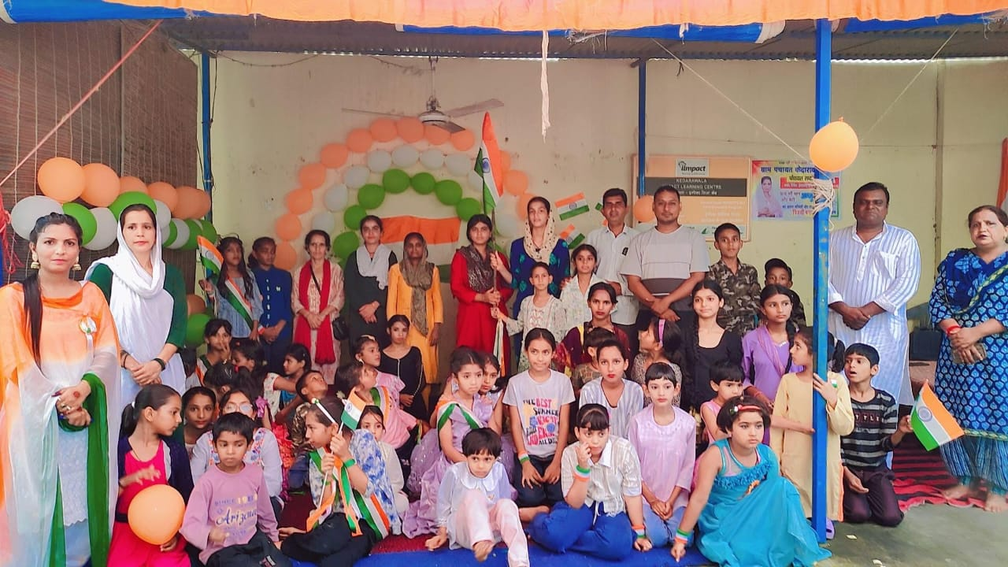
This was the academic year 2023-24, the students are still learning as per the levels of the previous QGA their levels are now somewhat increased, and are learning according to that, some of the highlights of this quarter are as follows: -
- We have put all the inputs given by the previous visits of donors and officials in mind and tried to meet the expectations of everyone from our project, by implementing all the necessary comments given by the management of IDS and IIMPACT
- The books for the class 1 and 2 of the state board have been provided to all the learning centres so that these books can help in their overall learning experience.
- We have started a mother literacy programme for all the community, during which we focusing on the FLN of all the adult females in all our project area, it helped our comuunity to achieve FLN along with the kids.
- The emphasis that we have been putting in the facilitation of the aarambh manch from last few months has started showing good result, during the quarterly training we have conducted sessions on the facilitation of the aarambh manch, now, most of our teachers are very well abled to conduct aarambh manch session on their own.
- Like every yearr, in this year also a remarkable time has been spent in improving the reading habits of the students, every day half an hour has been given to the students to read or write stories, we have also started giving library books to the students so that they can read at home also, and proper record of that has been recorded in a register.
- Teacher’s improved the quality of the TLM’s and also improved the display of the TLM’s at the centre along with the displaying of other materials like barkha series books, library etc.

